Delirium - raising awareness resources for support staff
March 2022

Delirium causes a short term confused state and can develop over hours or days. It is a common condition. 20% of adults in hospital experience delirium, 50% of people who have a hip fracture will experience delirium.

People can develop delirium anywhere such as in hospital, care homes and living at home. Delirium can affect memory, concentration and personality. It is a sign of an underlying illness. Delirium will usually improve, once the underlying illness is treated, but sometimes it can last for a while.

Raising awareness about delirium is important in order to ensure that the person at risk or who goes on to develop delirium, gets the right care and treatment.

Dementia United have collated the resources below, to enable you to find out more and raise awareness about delirium in order for you to take forward supporting people who are at risk of developing delirium as well as supporting people who go on to develop delirium to access the support they need.

Who are these resources for?

Our intended audience for these resources is health care assistants, support workers, dementia advisors, housing support and extra care housing staff, domiciliary and home care staff, reception and call centre staff.

What have we included in this resource?

We have included the long and short versions of our public facing delirium leaflet (along with a link to the translated resources).
We have also included links to training and raising awareness films and resources from other areas in the UK, which we hope will be of value.

Greater Manchester delirium leaflets

Dementia United have produced public facing leaflets, that are useful resources for staff to raise awareness about delirium. The print screen image on the next page, is from the long leaflet and outlines what it covers.

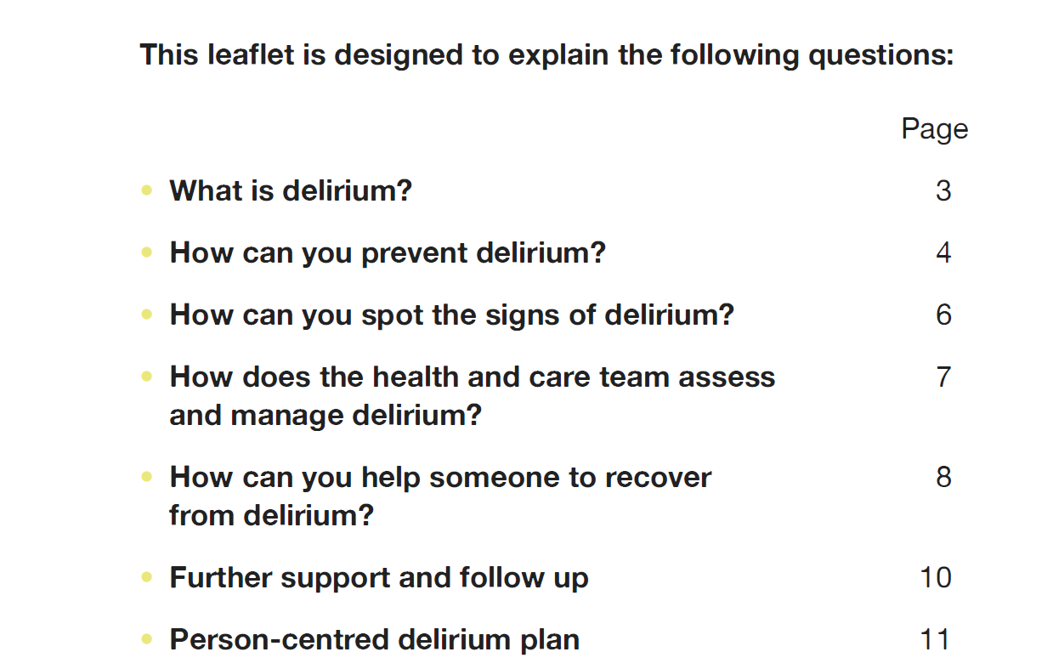

Long delirium leaflet can be accessed via the link here Greater-Manchester-delirium-Leaflet-long-version.pdf (dementia-united.org.uk)

Short delirium leaflet can be accessed via the link here Greater-Manchester-delirium-Leaflet-short-version.pdf (dementia-united.org.uk)
Translated versions of the shorter leaflet accessed via the link here Translated delirium resources - Dementia United (dementia-united.org.uk)

Awareness raising films

Dementia United have collated the resources that have been developed by other services that are very useful as training resources. You will see from the list below, that there are two very short animations, followed by a longer e-learning package that would need an hour to be able to complete.

- Delirium Awareness Animated video, suitable for staff (clinical and non-clinical) working in a variety of settings, including care homes and family carers.
  - Highlights the symptoms of delirium, identifying underlying cause(s) and strategies that can help. Key message: Suspect it, Spot it, Stop it. [4.5 mins]
icanpreventDELIRIUM Delirium Awareness Video HD - YouTube

- Delirium superimposed on dementia Animated video highlighting that people living with dementia are at increased risk of delirium.
  - Targeted at staff in wards or care homes. Uses animated case studies to show hyperactive, hypoactive and mixed delirium.
#DeliriumReady – Delirium Awareness and management Delirium Superimposed on Dementia - YouTube

E-learning module

E-Learning produced by West Yorkshire and Harrogate ICS. This e-learning provides the baseline knowledge and skills required by all staff working in health and social care settings and also for those working in an individual's own home (as well as family carers).

It is available on the e-learning for health platform. It takes approximately 50 minutes to complete and anyone can access it, you do not need to sign up for an account but you can if you wish to. Everyone receives a certificate at the end of the e-learning. Click on the link here e-LfH Hub to access the e-learning.

How to access the e-learning

We have provided some quick tips here. For more detailed guidance on working your way through the module please refer to the slides via the link here PowerPoint Presentation (yhscn.nhs.uk)

When you click on the link e-LfH Hub, it takes you to this page as per the print screen below. Click on Play in the top right-hand corner

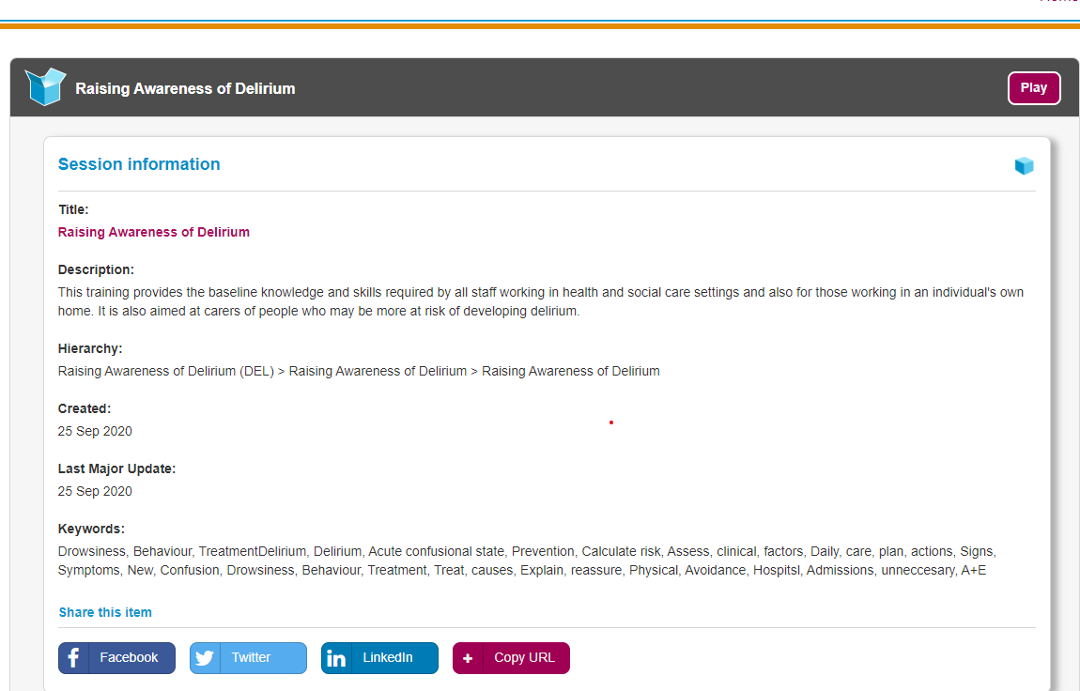

A text box as below will come up. Click Continue and you will be taken straight into the module.
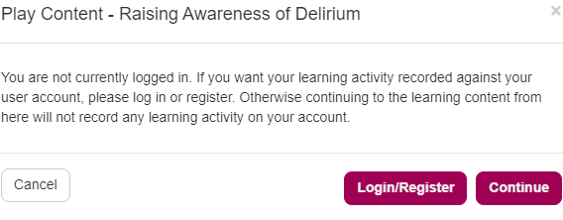

A box appears as below and you use the buttons at the bottom of the slide clicking Back Next to proceed through the training.

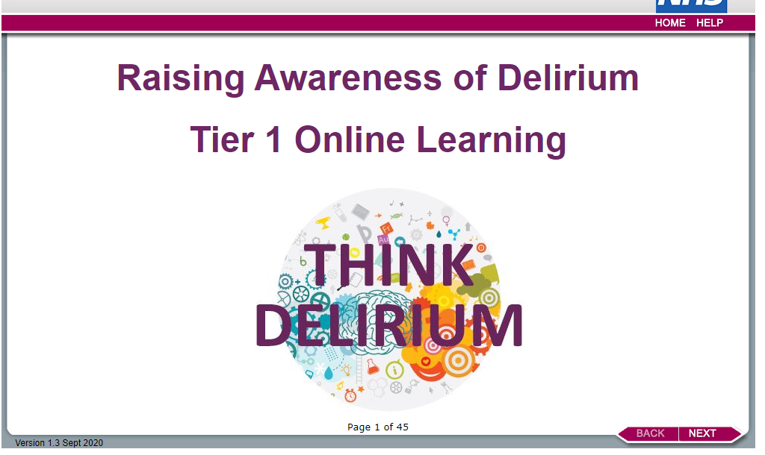

There are other training resources on the Dementia United website available via the link here Delirium toolkit training resources - Dementia United (dementia-united.org.uk)
eg resources from SCIE for Care Home Managers Why think delirium? (scie.org.uk)

Any questions about any of the resources, or if you want to find out more then please contact helen.pratt5@nhs.net

