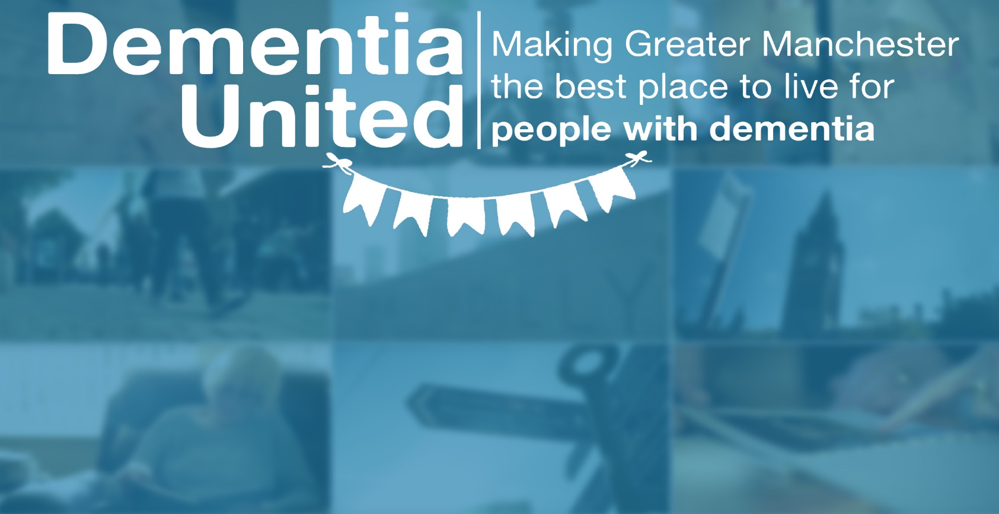

This is your opportunity to highlight an issue, concern, or suggestion to the Dementia United and Alzheimer's Society event panel. The panel will include Andy Burnham, Mayor of Greater Manchester; Kate Lee, Chief Executive Officer at the Alzheimer's Society; and a senior executive from the Greater Manchester Health and Social Care Partnership.

Get your voice heard to improve the lives of people affected by dementia.

My name is… Harry Harper

I live in… Rochdale

**What would make Greater Manchester a better place for people affected by Dementia?**

There should be more support and services for people with Dementia. Support and services that are in place need to be promoted and advertised better.

**Please return this form to** [**gmhscp.dementiaunited@nhs.net**](mailto:gmhscp.dementiaunited@nhs.net) **by Monday 3rd January 2022. Any problems please call 07521 868 370.**

The event is led by people with lived experience of dementia. If you would like to get involved, please get in touch!

I am a person living with Dementia

I am a carer of a person living with Dementia

I am a friend/family member of a person living with Dementia

I am a health and social care professional

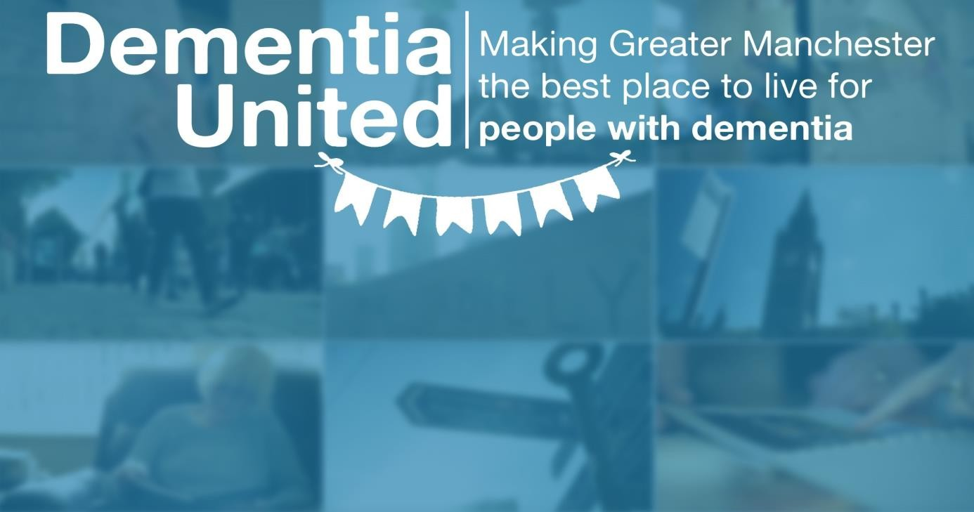

**Wednesday 9th February 2022. 10am to 2.30pm**

Join us for a Greater Manchester event; which plans to undertake a respectful reflection of the adverse impact of the pandemic on people affected by dementia as well as a refocus on recovery looking forward

**Come along to make sure your voice is heard**

The event is led entirely by people with lived experience. If you would like to get involved please contact: [gmhscp.dementiaunited@nhs.net](mailto:gmhscp.dementiaunited@nhs.net)

Entertainment from people with lived experience of dementia Hear from people affected by dementia

Speakers include the Mayor of Greater Manchester

To register your interest in attending the event and to receive further details please visit <https://bit.ly/3FveeRM>

Alternatively, you can contact Michelle Davies, Events and Engagement Manager on 07710 152805 [michelle.davies9@nhs.net](mailto:michelle.davies9@nhs.net) who will be happy to do this for you

The event is for people affected by dementia, as well as health and social

care staff and commissioners

The event is available to attend in person (priority will be given to people affected by dementia) and to access online

The event will be held at a central Manchester venue (TBC)



