

**Resources to support delivery of the Greater Manchester dementia care pathway train the trainer workshop**

**Greater Manchester Dementia Pathway**

**Train the trainer supplementary materials**

**September 2022**

This resource is intended to support you to deliver a train the trainer workshop within your services on how to use the Greater Manchester dementia care pathway. We hope you find this information of value and let us know if you require any further support.

**Useful resources for sharing the pathway and delivering training**

* Link to the pathway website can be found here: [Greater Manchester's Dementia Care Pathway (gmdementiaresources.org.uk)](https://www.gmdementiaresources.org.uk/)
* A flyer that you can print off and share as part of your training can be found here <https://dementia-united.org.uk/wp-content/uploads/sites/4/2022/05/Greater-Manchesters-Dementia-Care-Pathway-May-2022.pdf>
* Further information on the Greater Manchester dementia care pathway can be accessed via the Dementia United website [Greater Manchester’s Dementia Care Pathway - Dementia United (dementia-united.org.uk)](https://dementia-united.org.uk/greater-manchesters-dementia-care-pathway/)
* Power point slides for the train the trainer workshop can be accessed here: 
* A recording of the workshop can be found on our YouTube channel here: <https://youtu.be/e4Qp7isv-Js>

**Extra resources and notes for some workshop slides can be found below**

**Slide#2:**

Our networks and stakeholders

**Slide# 3:** **Impetus for the development of the Pathway – why was it developed?**

The resources listed below, formed the basis for the development of the standards within the dementia care pathway:



* Greater Manchester dementia assurance report. Key lines of enquiry in all ten localities to scope out and undertake an analysis of the services and support available across Greater Manchester:
* A fragmented pathway experiences of the South Asian Community and the dementia care pathway: A care giver’s journey: <https://www.tide.uk.net/resources/bame-resources/a-fragmented-pathway-by-shahid-mohammed/>
* The dementia care pathway, full implementation guidance: <https://www.rcpsych.ac.uk/docs/default-source/improving-care/nccmh/dementia/nccmh-dementia-care-pathway-full-implementation-guidance.pdf?sfvrsn=cdef189d_8>
* From diagnosis to end of life: the lived experience of dementia care and support: <https://www.alzheimers.org.uk/about-us/policy-and-influencing/from-diagnosis-to-end-of-life>
* Long term plan Greater Manchester dementia report:



**Slides #4/5: How did Greater Manchester agree the pathway standards?**

We developed the standards with a wide range of stakeholders, that included people with lived experience, service providers, commissioners, health and social care staff and voluntary sector organisations. We then worked on seeking feedback on these standards and priorities for Greater Manchester with feedback events and an online survey.

* The Feedback report can be accessed here: [Dementia-Care-Pathway-feedback-ReportApril-2021.pdf (dementia-united.org.uk)](https://dementia-united.org.uk/wp-content/uploads/sites/4/2022/05/Dementia-Care-Pathway-feedback-ReportApril-2021.pdf)

A total of seven feedback events were held, just under a third of the planned number. These were undertaken by:

* Age UK in Trafford
* Oldham BAME Dementia Advisor – two events
* Making Space Oldham and Oldham’s Commissioner
* Stockport Dementia Champions and Stockport’s Commissioner
* EDUCATE in Stockport two events.

We also provided the written version of the pathway as an online survey for people to feedback on. The pie chart indicates how many people fed-back on the pathway.

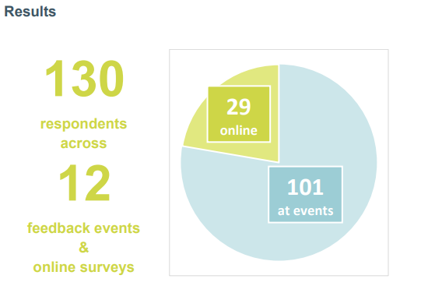

In February and March 2022, we hosted three digital user testing workshops via Zoom and MS teams as well as meeting with key stakeholders. 67 people attended these sessions and fed-back on the digital version which informed the final webpage.

The table below outlines some of the suggestions and actions we took after collating feedback from these user testing workshops.

| **Recommendation** | **Action** |
| --- | --- |
| It was suggested that the resource be translated and modified to allow ease of access for foreign language speakers and those with sensory disabilities. | Although we didn’t have capacity for large scale alterations such as this prior to launch, we recognise how important it is that this resource be accessible to all Greater Manchester residents. Therefore, we will reconsider this alteration as further resources become available. |
| Where no local offer of support exists, please include links to regional and national resources. | Our team have included a range of regional and national support offers. |
| Could we provide advice on specific symptoms | The website’s search function will find any recommendations which reference specific symptoms searched for if they are present. However, the resource is not designed as a medical resource so will be unable to cover all specific symptoms/medical information. |
| Be aware of digital exclusion and acknowledge/account for this where possible. | Although the resource is digital, all recommendations and support offers are printable. We’ve worked with Radical to ensure that all recommendations can be downloaded as PDF’s and printed in black and white (to reduce ink waste). It is our intention that clinical professionals (GPs, dementia advisors, nurses, memory assessment service teams etc) can access this resource and provide patients with printed information relevant to their circumstances and interests.  We’re also supporting several professionals and services to implement this resource through locality connections. |
| Can we include ‘share via social media – Facebook/twitter etc’ button on resources for ease of sharing? | We’re discussing this as a possible update in a future iteration of the website |
| Ensure resource is shared widely | We’re currently developing a communications plan to ensure that this resource is shared widely. If you would like to share this with your colleagues and contacts the following resources are available:  An explanation of the resource and how it was developed can be found here: <https://dementia-united.org.uk/greater-manchesters-dementia-care-pathway/>  The pathway website can be accessed here: <https://www.gmdementiaresources.org.uk/>  A flyer advertising the resource can be accessed and downloaded here: <https://dementia-united.org.uk/wp-content/uploads/sites/4/2022/05/Greater-Manchesters-Dementia-Care-Pathway-May-2022.pdf>  We’re also developing a ‘train the trainer’ resource for clinical and professional users to better understand the platform and to enable them to train other users. This will be available to watch from October |
| Could we include diagnosis figures and other data i.e. post diagnostic support for each borough. | We’ll be working closely with colleagues from each GM borough to explore this request and how to implement this. |
| Quick access to information regarding crisis services | Following several suggestions that information regarding crisis support should be prominent and easily accessible on our webpage we have added a crisis support tab to the top of the page – this will be accessible from any page of the website: <https://www.gmdementiaresources.org.uk/crisis>  We’ll also be taking forward developing this page further, taking up offers from colleagues who attended the workshops. |
| Can we feedback to locality commissioners and service providers what people in each borough are searching for? | We’re in the process of updating the website to allow users to search for specific recommendations within each Greater Manchester borough. Part of this discussion will cover how to access search terms entered into these search bars. |
| How will the resource be kept up to date | We use feedback and contact us pop ups when people log in to the dementia care pathway. People can use these to feedback any updates or notify us of any omissions or errors.  Our steering group will review the feedback and consider actions as needed; which includes updating the live resource as appropriate |
| Several attendees requested further information regarding the development of the pathway. | The dementia care pathway has been co-produced with wide engagement with 130 people affected by dementia in 2022. A report following this feedback, can be accessed via the link here [Dementia-Care-Pathway-feedback-ReportApril-2021.pdf (dementia-united.org.uk)](https://dementia-united.org.uk/wp-content/uploads/sites/4/2022/05/Dementia-Care-Pathway-feedback-ReportApril-2021.pdf) |

We’ll be working with partners across Greater Manchester including people with lived experience, to ensure that suggestions and feedback which were not addressed prior to launch in June 2022 will be considered for action in the future.

**Slide #7: How were the different priority status levels agreed for the pathway?**

Each standard on the pathway has been assigned a priority status, these are:

* *Required to provide*
* *Should be provided*
* *Ambition to provide*

Dementia United worked with a wide range of stakeholders to agree which guidelines would be used to set the priority status of our recommendations. These include:

* **Required to provide**: Memory Services National Accreditation Programme, legislation e.g. The Care Act, CQC requirements, NICE and SCIE
* **Should be provided**: Non-mandated emerging evidence in NICE and other research, CQC standards
* **Ambition**: emerging evidence, best practice which may be regional, feedback from lived experience

Please feel free to feedback on the above and also when using the pathway as we appreciate that evidence and best practice will be constantly changing and we need to reflect this within the pathway.

**Slides #9 to #12: How can the dementia care pathway support me and those I support?**

You can find several examples of how the dementia care pathway can be used by practitioners and those with lived experience of dementia on the following slides:

* Commissioners: **Slide #9**
* Dementia Advisors: **Slide #10**
* General Practitioners: **Slide #11**
* Lived experience users: **Slide #12**

We suggest that if your target audience falls outside the user groups listed above you should add further examples of your own which are relevant to those attending your workshop. We hope you find the examples we have provided useful and can use these to create further examples of your own.

**Are there any frequently asked questions I can refer to?**

You will find more information in our Frequently Asked Questions

[Greater Manchester's Dementia Care Pathway (gmdementiaresources.org.uk)](https://www.gmdementiaresources.org.uk/faq)

**Navigating the pathway**

**Main page**

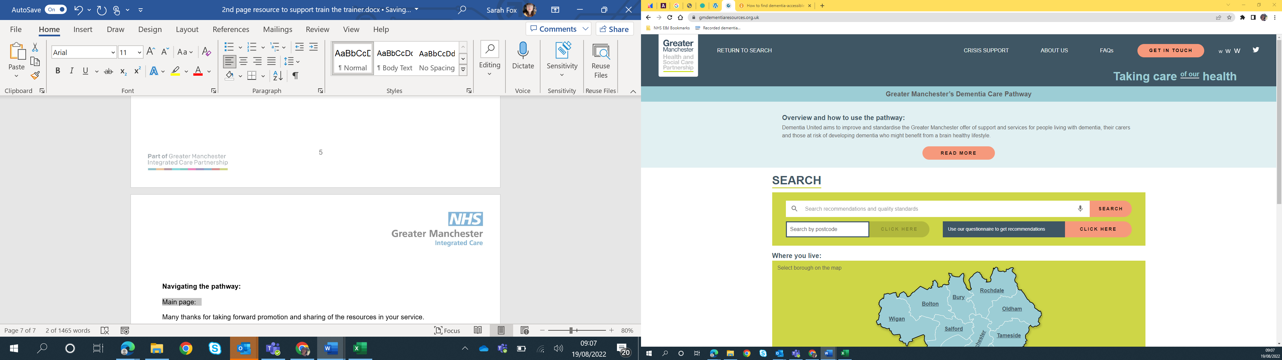

**Tabs (at the top of the page)**

* **Return to search** will always take you back to this page
* **Crisis support:** Details of local and national support services for anyone in crisis.
* **About us:** Information on Dementia United, who we are and what we do.
* **FAQs:** A list of frequently asked questions.
* **Get in touch:** An online form to contact the Dementia United team, you can use this to add your service to the pathway, comment on current content or ask us about our work
* **Text size:** The three Ws can be used to change the size of the text displaying on the website
* **Twitter:** The twitter logo takes you to Dementia United’s twitter account @dementiaunited

**Searching: local vs regional/national**

The website is set up to allow you to search our recommendations either locally, listing offers available in each Greater Manchester borough, or regionally, listing all recommendations without any local offers.

**Local search**

There are two ways to search our recommendations for local offers

1. Type your postcode into the ‘search by postcode’ box in the search bar
2. Click on the borough you want to search on our interactive map

Each borough’s page contains a short description of that localitie’s dementia strategy and offers, followed by selected contact details. Then, below these details, you can access our recommendations either by searching for a topic of interest or by clicking through the stages of the dementia well pathway (see images below).

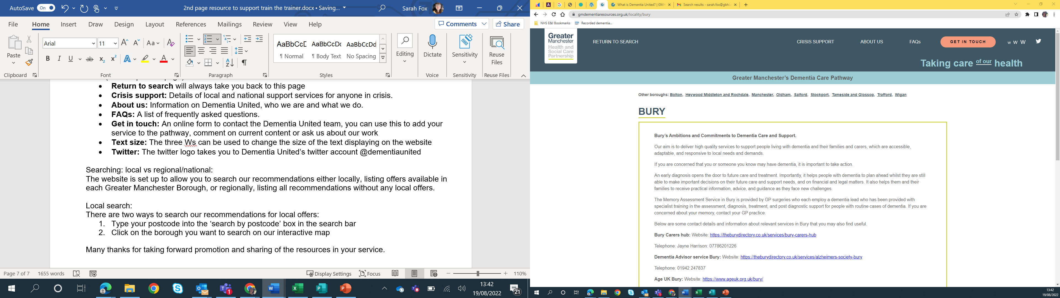

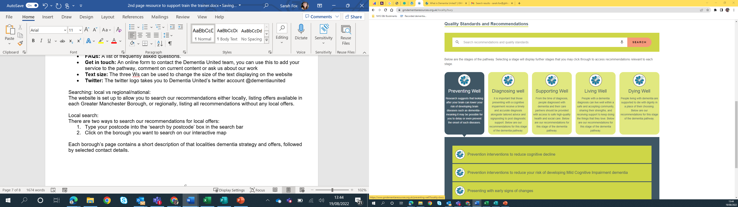

Recommendations contain the following information/options:

1. **Priority:** this is the recommendation’s priority rating, it will be either Required, Should or Ambition
2. **Download:** clicking this will download all in formation linked to this recommendation to your computer/device as a PDF file.
3. **Print:** This will allow you to print the recommendation and all associated information.
4. **Recommendation title**
5. **Recommendation narrative**
6. **Offerings in individual boroughs:** service/support offers linked with the recommendation). Note that if a borough does not have any offers linked to a recommendation no local offerings will display.
7. **Regional offerings:** service/support offers available across Greater Manchester)
8. **National offerings:** services/support offers available nationally)
9. **Evidence:** selected evidence for recommendation
10. **Best practice resources:** selected best practice resources for recommendation

*Image: example recommendation*

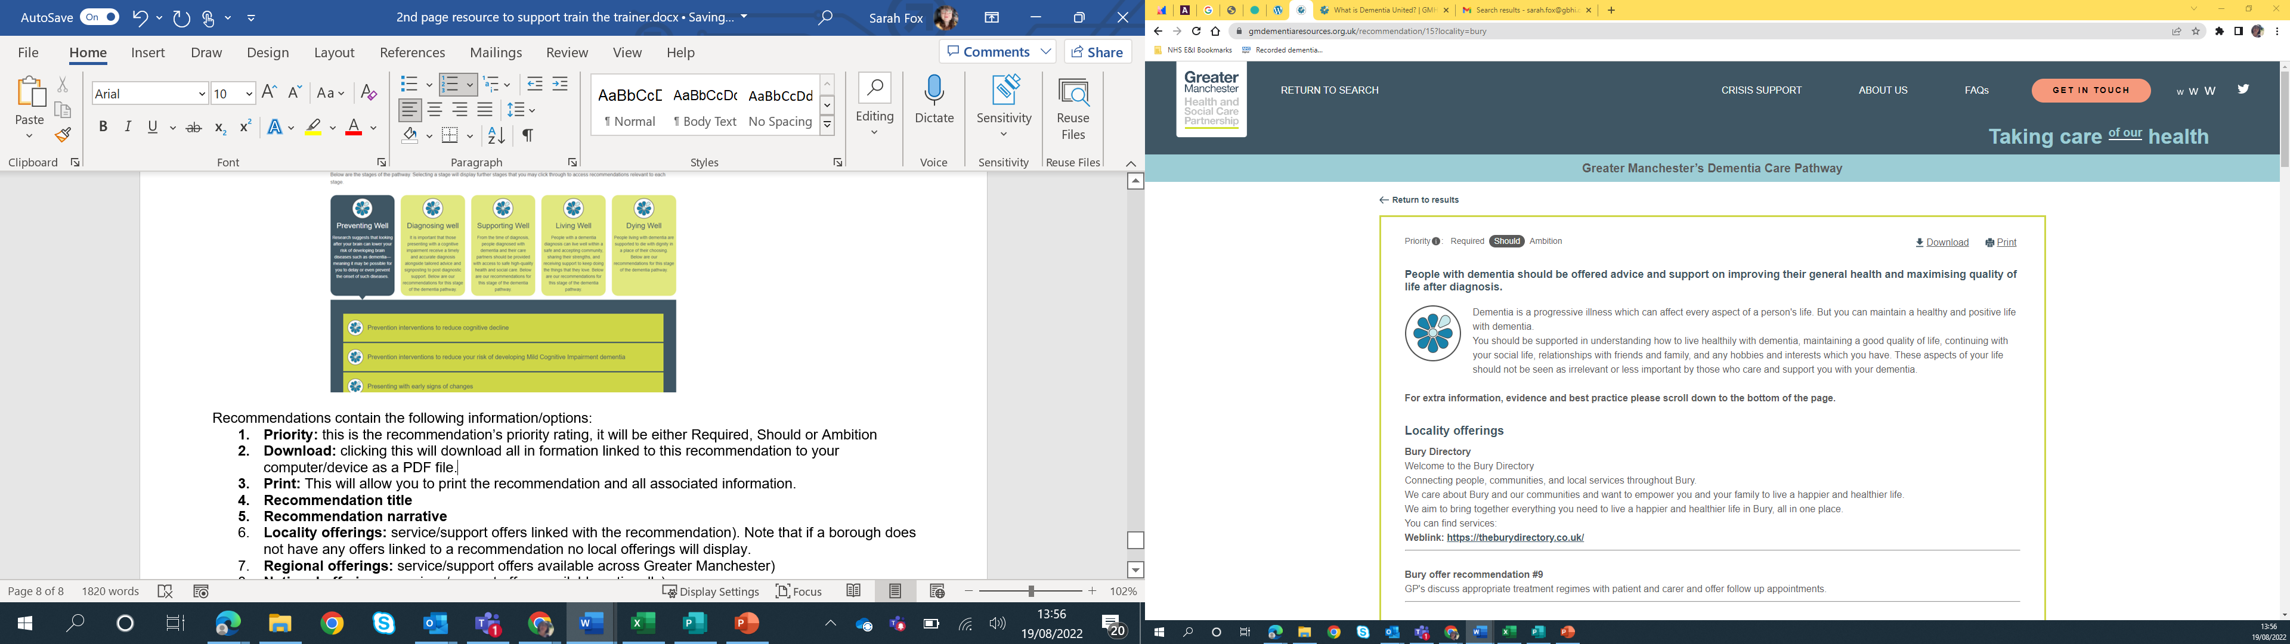

**Regional/national search only: Using the main page**

Using the search bar on the pathway’s main page will enable you to search all recommendations for topics of interest. However, searching in this way means that recommendations returned by the search will not contain local offers.

If you scroll to the bottom of the main page, you can also search recommendations by stages of the dementia well pathway

Recommendations accessed from the main page (rather than specific borough pages) will contain the following information:

1. **Priority:** this is the recommendation’s priority rating, it will be either Required, Should or Ambition
2. **Download:** clicking this will download all in formation linked to this recommendation to your computer/device as a PDF file.
3. **Print:** This will allow you to print the recommendation and all associated information.
4. **Recommendation title**
5. **Recommendation narrative**
6. **Regional offerings:** service/support offers available across Greater Manchester)
7. **National offerings:** services/support offers available nationally)
8. **Evidence:** selected evidence for recommendation
9. **Best Practice resources**

For reference see below for a list of all recommendations against the stage of the dementia well pathway they are associated with (note that the same recommendation may be linked with multiple stages of the dementia well pathway, so will be duplicated)

**Preventing well**

* People in mid-life are advised that the risk of developing dementia can be reduced by making lifestyle changes
* Arts and creative therapies are to be available to people experiencing cognitive decline.
* Dementia screening will be offered as part of your NHS health checks and dementia screening will be specifically documented in these checks.
* Mild cognitive impairment clinical syndrome may be applied to some patients presenting with decline in their cognition. Once identified they are offered support and resources to enable them to adjust to the difficulties as a result of cognitive decline, including accessing prevention strategies and access to research.

**Diagnosing well**

* At least two-thirds of people with dementia will receive a formal diagnosis.
* memory assessment services to respond within two weeks of receiving referral.
* Staff who work with older people will be trained to spot the signs of mild cognitive impairment and dementia and know how to refer for assessment and offer the support the person needs, whilst awaiting this assessment.
* Earlier diagnosis and interventions post diagnosis, will enable people to live more independently for longer.
* Clear information is made available to people with dementia, carers, and healthcare practitioners about the memory assessment service.
* The assessment of people at risk of dementia should be a supportive and informative experience.
* The memory assessment service follow up those who have not attended an appointment or who are difficult to engage.
* People with dementia are provided with a diagnosis for the specific dementia type.
* GP practices to establish and maintain a register of patients diagnosed with dementia.
* Any carer who appears to have a need for support should be offered a carer’s assessment by the local authority.
* Anticholinesterase medication for dementia is prescribed where appropriate.
* People with dementia should receive a diagnosis and begin treatment within 6 weeks of referral.
* Upon discharge from memory assessment services to primary care, a dementia advisors is planned in advance, with a specific joint working protocol/shared care pathway for medication.
* Arts and creative therapies are to be available to people experiencing cognitive decline.
* Mild cognitive impairment clinical syndrome may be applied to some patients presenting with decline in their cognition. Once identified they are offered support and resources to enable them to adjust to the difficulties as a result of cognitive decline, including accessing prevention strategies and access to research.

**Supporting well**

* People living with dementia have a care plan created or reviewed at least once every 12 months.
* The dementia care plan is available digitally to professionals involved in support.
* All staff will be given training about dementia relative to their level of interaction.
* Management and support strategies that may be used for complex advancing symptoms of dementia are considered and discussed as part of collaborative shared decision making with carers and family members
* People living with dementia and their carers have the opportunity to participate in research.
* People who drive are informed of the necessity to report the diagnosis to the DVLA and are provided with information on alternatives if they are advised to stop driving.
* People with dementia and their carers are helped to access financial advice and support to claim any financial help they are entitled to.
* A named service for dementia advice and navigation is provided
* People with dementia should be offered advice and support on improving their general health and maximising quality of life after diagnosis.
* People diagnosed with dementia are provided with information on delirium and their increased risk of developing the condition
* The association between dementia and hearing loss is recognised and services are provided to diagnose and treat hearing loss in those with dementia.
* The association between dementia and the risk of developing a higher rate of tooth decay and gum disease is recognised and services provided.
* People with dementia and carers will be able to access appropriate multi-disciplinary support at times of crisis through a clear, single point of contact
* All staff working more closely with people with dementia and carers have an understanding of behaviour that challenges (BtC) and know where and how to offer support or refer on as needed.
* Arts and creative therapies are to be available to people experiencing cognitive decline.
* People with dementia and cognitive impairment are enabled to access to the arts and heritage at all stages of the dementia well pathway.
* Family members are provided with information on what to expect when a loved one is admitted to an inpatient mental health unit for behaviour that challenges in the context of dementia.
* People with dementia should have the same access to community health and care services as others with complex support needs.
* People with dementia and carers are enabled to access and connect to Social Prescribing offers and/or community based support.
* In Greater Manchester, the police's Herbert Protocol is completed in advance, which enables people to be safe and found, if they go missing.
* Greater Manchester's principles of dementia navigation underpins all services offering this role.

**Living well**

* People with dementia who develop symptoms that cause them significant distress, or develop behaviour that challenges us (BtC), are offered an assessment at an early opportunity to establish generating and aggravating factors.
* Suitable social and peer support groups are locally available for people living with dementia and carers.
* Fostering a dementia friendly society is inclusive and accessible for all
* Enabling the person with dementia and their family in managing their own health and care, adopting a number of strategies and accessing resources.
* Appropriate assistive technology should be explored and offered for those whom it may benefit.
* People with dementia and carers are enabled to access music in a number of settings, at all stages of the dementia well pathway.
* Earlier diagnosis and interventions post diagnosis, will enable people to live more independently for longer.
* People with dementia and carers are enabled to access and connect to social prescribing offers and/or community-based support.
* Psychosocial therapies for improving and maintaining cognitive functioning should be offered to those living with mild-to-moderate dementia.
* Arts and creative therapies are to be available to people experiencing cognitive decline.
* People with dementia and cognitive impairment are enabled to access to the arts and heritage at all stages of the dementia well pathway.
* People with dementia are enabled to take part in leisure activities based on individual interest and choice.
* People living with dementia and their carers should be supported to discuss future planning.
* People with dementia have the right to personal choice over where, and how, they live; which includes conversations with carers about their home and it meeting their needs when planning ahead.
* Dementia is a sub-set of frailty targets for general hospitals and must be taken into account.
* All care homes should adopt the Red Bag Scheme.
* Using personal information to improve care when the person with dementia is not able to provide this
* Management and support strategies that may be used for complex advancing symptoms of dementia are considered and discussed as part of collaborative shared decision making with carers and family members.
* People with dementia admitted to hospital for acute care must always be assessed for the possibility of delirium.
* Timely review and monitoring is needed of people with delirium to confirm that they are improving and responding to treatment, where cognitive impairment persists people are referred on for further assessment.
* People with known dementia using acute and general hospital inpatient services have their diagnosis of dementia recorded and shared along with access to liaison services that specialise in the management of dementia and older people’s mental health, when this is clinically indicated.
* Involving a family carer from the moment of admission to hospital until the moment of discharge has been proven to give better quality of care and improved outcomes.
* In Greater Manchester the standard is for John’s Campaign: enabling carers to stay with and support patients in hospital.
* If a person does not qualify for NHS Continuing Healthcare, the NHS may still have a responsibility to contribute to that individual’s health needs – either by directly commissioning services or by part-funding the package of support.
* Living well with dementia in care homes
* The percentage of people diagnosed with dementia prescribed anti-psychotic medication should be minimised.
* People with dementia and carers will be able to access appropriate multi-disciplinary support at times of crisis through a clear, single point of contact
* All staff working more closely with people with dementia and carers have an understanding of behaviour that challenges (BtC) and know where and how to offer support or refer on as needed.
* Family members are provided with information on what to expect when a loved one is admitted to an inpatient mental health unit for behaviour that challenges in the context of dementia.
* People with dementia should have the same access to community health and care services as others with complex support needs.
* In Greater Manchester, the police's Herbert Protocol is completed in advance, which enables people to be safe and found, if they go missing.
* All staff will be given training about dementia relative to their level of interaction.
* Greater Manchester's principles of dementia navigation underpins all services offering this role.
* Access to psychological therapy via IAPT for adults presenting with depression and/or anxiety.

**Dying well**

* Ensure safeguarding issues are identified and appropriately handled.
* Identify people living with dementia who are nearing the end of their lives.
* GPs should maintain a palliative care register for those in the last 12 months of life.
* People living with dementia should not be placed out of area for non-specialist mental health acute care.
* GP has regular (at least 3 monthly) multidisciplinary case review meetings where all patients on the palliative care register are discussed.
* Shared decision-making in personalised care and support planning.
* Personal health budgets are required to be offered - as part of NHS funded care, as well by social care funded support with individual budgets.
* Carers are supported and enabled to make decisions about their wish to continue to care.
* After a person has died, it is important that carers are supported to grieve.
* Bereaved carers are provided with social prescribing.

**Many thanks for taking forward promotion and sharing of the resources in your service.**

Contact us on: [gmhscp.dementiaunited@nhs.net](mailto:gmhscp.dementiaunited@nhs.net)