**Dementia United**

**Dementia Carers Expert Reference Group (DCERG)**

**Member Role Specification**

**About Us**

Dementia United is the NHS Greater Manchester Integrated Care flagship programme for dementia. We work alongside clinicians, charities, localities, professionals, those living with dementia, families, friends and care partners to make our region the best place to live for people living with or who are caring for someone with dementia.

**About DCERG**

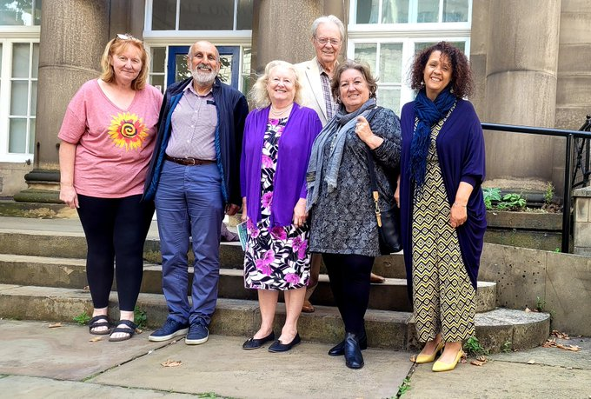

Within their individual localities and networks, DCERG members ensure the carers collective voice is represented in the feedback of the development and implementation of all Dementia United work streams across Greater Manchester. Currently we are actively seeking new members from**: Bolton, Bury, Salford, Wigan, Trafford, Oldham, HMR & Tameside as well as from BAME & LGBTQ+ communities across Greater Manchester.**

**About the role**

H

You can [find out more about our work on our website](https://dementia-united.org.uk/wp-content/uploads/sites/4/2023/03/Dementia-and-Brain-Health-Delivery-Plan-2023-to-2025.pdf)

**DCERG members get involved with and influence our entire programme. They are equal partners in Dementia United’s governance structure and are represented at our Steering and Task & Finish Groups, and on multiple additional projects.**

**About You**

You will be over 16 and a current or previous carer for someone living with dementia. No previous experience is necessary.

**“Hi, I’m Ruth Turner, the Chair of DCERG. We do such great work with Dementia United; we’re genuinely listened to, and our contributions make a big difference. We’d love you to come and join us!”**

**The Impact You’ll Make**

DCERG members make a significant impact! We’ll give you all the support you need from the moment you join, with an experienced member as your named ‘Buddy’ to guide you and answer all your questions. The DCERG group is very supportive but it’s not a support group – members are here to influence the dementia programme across Greater Manchester, and we want to hear your voice. Dementia carers are ‘experts by experience’ and we know they are best placed to advise NHS Greater Manchester Integrated Care on the needs of people living with dementia.

**What’s Involved**

This year our DCERG Dementia Carers Bounce Back Fund gave away £22,000 to over 20 dementia carers groups across GM for a range of Covid recovery projects!

DCERG members meet online monthly on the 3rd Monday in the month, from 11am to 1pm. Members can also attend other Dementia United Governance Meetings held Bimonthly, and other ad hoc project groups as required.

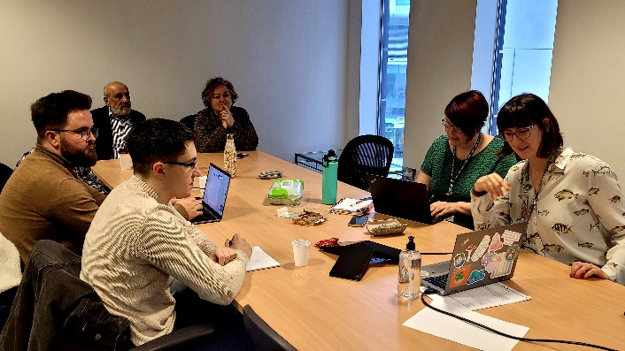As we start to open up again, some meetings are now taking place in person. We also have social meet ups!

Members are compensated for their time, and we can also cover carers respite costs where appropriate.

Members with DU team at a Dementia Wellbeing Plan Film Script Development Meeting

**How to Apply**

If you are interested, please contact Amal Morsi. You can either email Amal [amal.morsi1@nhs.net](mailto:amal.morsi1@nhs.net) or telephone her for an informal discussion t: 07917511678