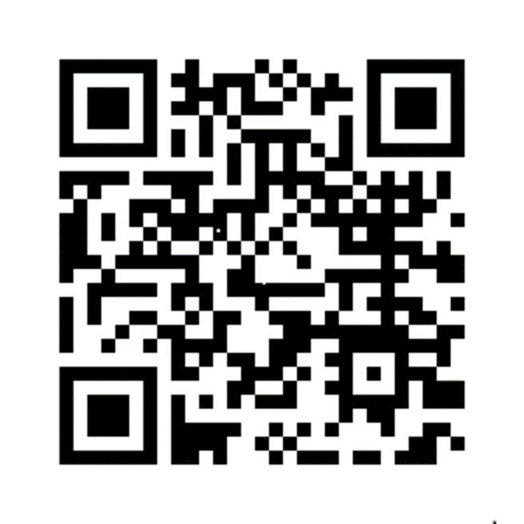

**Greater Manchester’s Dementia**

**Care Pathway**

**We’ve been told that finding the right information and support when you’re living with dementia, caring for someone living with dementia or delivering services for people living with dementia can be difficult. That’s why we’ve developed the pathway.**

To find out more visit our pathway website via the link here [www.gmdementiaresources.org.uk/](http://www.gmdementiaresources.org.uk/) or scan the QR code

Dementia United dementia-united.org.uk/ worked with people living with dementia, their care partners, and professionals in Greater Manchester to **find out what matters to them** and **co-produced** a set **of 75 recommendations** which cover all stages of the dementia journey. These recommendations are central to the dementia care pathway.

Each recommendation includes **information on how to access support and services across Greater Manchester and nationally**, which you can search for in the dementia care pathway. It includes evidence as to why the recommendation is important and examples of best practice showing how it has been successfully implemented.

**Whether you’re looking for local information for yourself or a loved one, you’re a commissioner looking for best practice guidance or you work in health and social care and are looking for the evidence behind different interventions, you’ll find it in our dementia care pathway.**

If you’d like more information, you can also contact us via our email gmhscp.dementiaunited@nhs.net