**Dementia United’s Living with Dementia Group**

**Would you like to join us?**

We’re actively seeking new members from communities across Greater Manchester to join our Living with Dementia Group

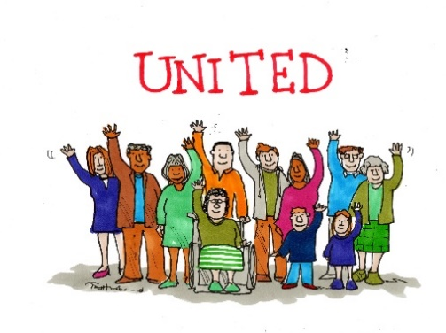

Cartoon by Tony Husband

Dementia United ensure the people living with dementia collective voice is represented in the feedback of the development and implementation of all work streams across Greater Manchester.

**About the Role**

We consider you an expert by experience. We know that you are in the best position to advise NHS Greater Manchester Integrated Care on the needs of people living with dementia.

Living with Dementia Group members get involved with, and influence our entire programme. Living with Dementia Group members are equal partners in Dementia United’s leadership structure. They are also represented at our Steering and Task & Finish Groups, and on multiple additional projects.

Living with Dementia Group members meet online regularly. Members are reimbursed for their time.

**How to Apply**

Please contact Amal Morsi for an informal no obligation discussion.

e: [amal.morsi1@nhs.net](mailto:amal.morsi1@nhs.net)

t: 07917511678