**Free delirium online training for family members and carers**

**Delivered alongside carers with lived experience**

**Thursday 16th May 4.30 – 6:30pm** during Dementia Action Week

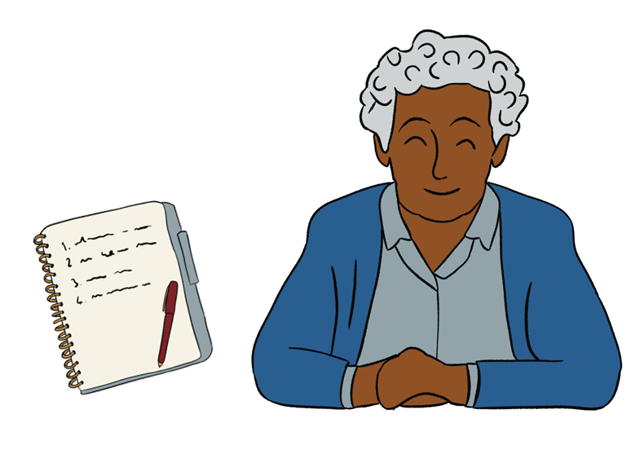

Illustration by Glen Cutwerk [www.glencutwerk.com](http://www.glencutwerk.com)

Delirium causes a short term confused state and can develop over hours or days. It is a sign of an underlying illness. **Older people** and **people with dementia** are at **greater risk of developing delirium**.

|  |  |
| --- | --- |
| **Open to all family members and carers**  **Location: Online (Microsoft Teams)**  **To book on please email** [**gmhscp.dementiaunited@nhs.net**](mailto:gmhscp.dementiaunited@nhs.net)  **We will send all details of how to join via email.** | **The training will cover:**   * **What is delirium?** * **How to prevent delirium** * **Identifying the causes and signs** * **Getting help when you need it** |

**For more information**

See our [delirium top tips for carers and family members guide](https://dementia-united.org.uk/news/2024/02/22/delirium-top-tips-for-carers-and-family-members/).

You can [find out more about our delirium programme here](https://dementia-united.org.uk/delirium/)

Any questions email [gmhscp.dementiaunited@nhs.net](mailto:gmhscp.dementiaunited@nhs.net)