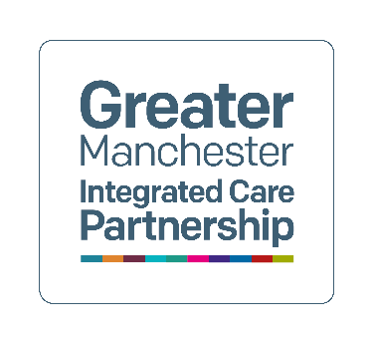

Creativity in Care Homes Project 2022/23

May 2024

Small subtitle (delete if not needed)

**Contents**

Background 1

What we did 2

How the care homes used the funding 2

Wingates Residential Care Home – Bolton 2

Southlands Care Home – Bolton 3

Belong Atherton Care Home – Wigan 3

Laburnum House – Oldham 4

Highfield House & Highfield Manor – Rochdale 4

Key benefits 5

# Background

Troubling behavioral and psychological symptoms occur in approximately 90% of people living with dementia, these can cause significant distress for the person living with dementia and challenges for those caring for them (Ballard et al., 2009). Evidence is growing to suggest that arts-based activities can improve a broad range of outcomes for people living with dementia, including wellbeing, quality of life, cognition and communication; and may reduce harmful behavioral and psychological symptoms (Jones et al., 2020). Creative activities might be a cost-effective method to improve wellbeing for those living with dementia in care homes and to relieve pressure on care providers.

The creativity in care homes project, a joint initiative between Adult Social Care, Creative Health, and Dementia United, was developed to explore the feasibility of embedding creative care into care homes across Greater Manchester. The project, launched in December 2022, aimed to support care homes to explore creative and sustainable approaches to promoting the wellbeing of people living with dementia by supporting their physical, social, and emotional needs.

A small grant fund of £50,000 was set up, offering a one-off grant of up to £15,000 per applicant. After an open call for proposals, eleven applications were considered with selection criteria favoring those care homes with the highest number of residents living with dementia, and with detailed proposals that considered sustainability. Dementia United’s Dementia Carers Expert Reference Group were involved in all aspects of the application process, sharing their invaluable lived experience with the team to aid development and project selection.

The creativity in care homes work was one of three small grant schemes funded by Dementia United and prioritised within our two-year strategic delivery plan. You can [find out more about the other two grant schemes( Big Brain Health Fund and the Bounce Back Fund) on our website](https://dementia-united.org.uk/brain-health-wellbeing-funding-initiatives-2022-23/)

# What we did

£50,000 was awarded between five care homes based on: their creative proposal; the sustainability of the project; having residents living with dementia to benefit from the project. We worked with a curator / producer who worked with care homes to develop and deliver their plans and select appropriate artistic and/or creative collaborative partners.

# How the care homes used the funding

## Wingates Residential Care Home – Bolton

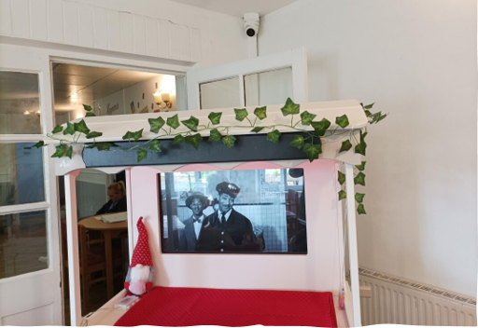

* Developed a ‘Jolly Trolley’ which is a mobile interactive entertainment trolley. They also paired with a local artist who developed a series of creative activities and art sessions for the residents to partake in.
* The trolley is mobile so can go from room to room so all residents, even those who are bed bound, can use it

## Southlands Care Home – Bolton

**A person using an integrative computer screen

**

* Utilized the dining room for activities and set up handicrafts when the artist visited.
* Developed an activities table that was used daily for a variety of activities eg games, skype, music programmes.

## Belong Atherton Care Home – Wigan

**A balcony with plants and a chair

 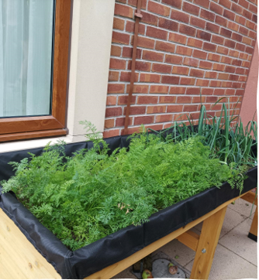**

* Staff spent time creating a sensory garden in a relaxing atmosphere
* Residents and families grow vegetables in the garden
* Residents spend time outside when the weather permits - having lunch, mowing the lawn, enjoying activities including football as well as sensory activities with all the different plants smells.

## Laburnum House – Oldham

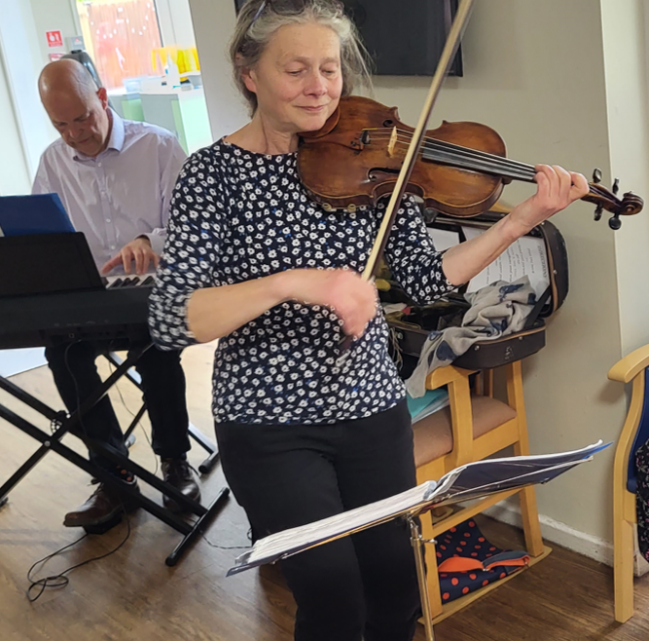

David Petri (playing keyboard) and Caroline Abbott (playing violin) from the Halle Orchestra, Manchester

* Put the funding towards the development of a music/ sensory room, as well as commissioning musicians to deliver interactive sessions. They also funded sessions for residents and staff training.

## Highfield House & Highfield Manor – Rochdale

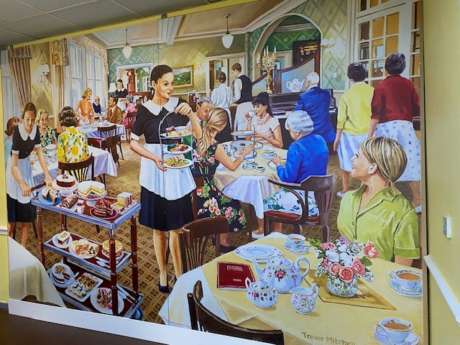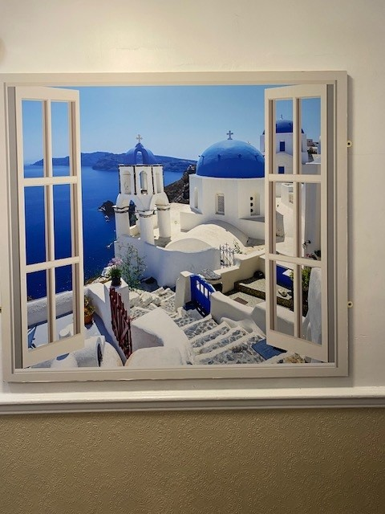

* Created wall art that puts the home in an exotic setting - beaches, palm trees, mountain views or even Santorini.
* For someone living with dementia, this gives them the feeling of space and for other residents it allows them to reflect or reminisce about holidays.
* Walking for exercise with staff, and discussing the views, is now a regular activity at Highfield.
* Set up a “pub” that’s a cosy space for residents to do activities or relax with visitors.
* Wall art in the dining room extends the area, giving it a feel of being out for tea, making the mealtime experience more exciting. Residents are more inclined to sit down at mealtimes rather than walk round with their food.

# Key benefits

Greater Manchester is recognised as a leader in ageing well and in creative health, and creativity in care homes embodies Greater Manchester’s ambition to be one of the best places in the world to grow old and to be a place where culture and creativity are at the heart of how we care for others.

Residents were observed to eat and sleep better, they exhibited less anxiety, were more engaged with their environment, staff and other residents also were generally happier and more relaxed. Staff also benefitted from working in calmer environments and found it easier to engage with residents.

Each of the five projects demonstrated that, with only minimal investment, creative activity can improve the daily lives of residents and the wellbeing and job satisfaction of staff. Visitors also commented on the positive impacts for their relatives.