Are you a practitioner working in the VCSE, social care, or health system in Greater Manchester?

Do you have a special interest in dementia?

Do you support people affected by dementia?

**You are invited to join us for the next meeting of the**

**Greater Manchester**

**Dementia Practitioner Network**

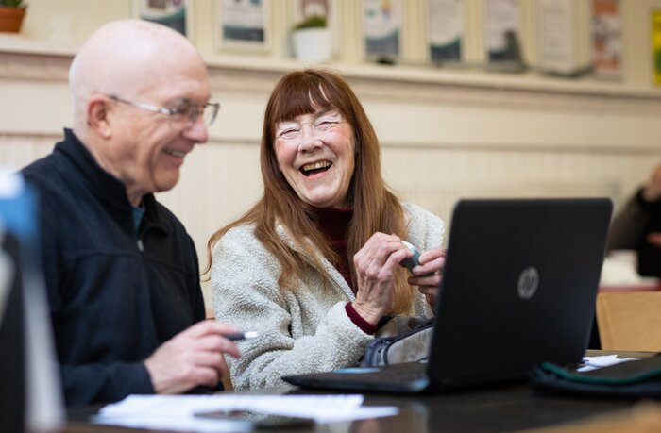

Thursday 12th December 2024,

2-3pm on Teams

Supported by Dementia United

Please email [gmhscp.dementiaunited@nhs.net](mailto:gmhscp.dementiaunited@nhs.net) to request a meeting invite or for more information

Title of document

To go in here

2022-2023