An opportunity to influence dementia care in Greater Manchester

There are vacancies in the Dementia Carers Expert Reference Group (DCERG)

The voice of lived experience. Helping shape services. Creating real change.
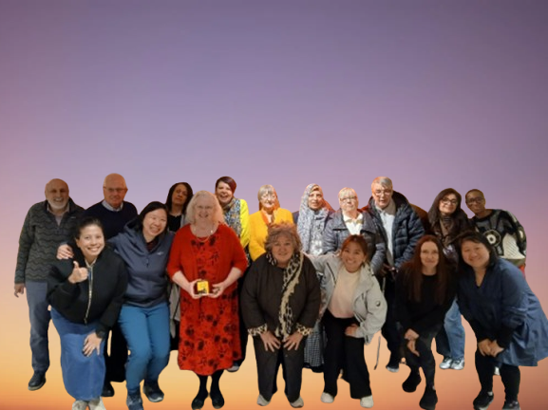

DCERG members are current or former carers, appointed to represent the 10 localities.

DCERG members are consulted by Dementia United, part of NHS Greater Manchester.

“We welcome applications from people of all backgrounds and particularly encourage individuals from underrepresented communities such as, people from ethnically diverse backgrounds, and the LGBTQ+ community.”

Commitment

- Monthly meetings (3rd Monday, 11am to 1pm)
- Influence improvement projects across Greater Manchester
- Represent your area and community

Your time and involvement are valued, and an attendance payment is available


To find out more please contact Amal Morsi. You can either email Amal amal.morsi1@nhs.net or telephone her for an informal discussion: 07917511678. Scan the QR Code to find out more about how to get involved.

