
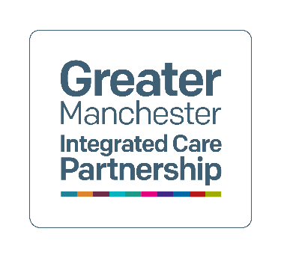

Dementia United
Project leads: Helen Pratt and Professor Emma Vardy
October 2025

The Greater Manchester Singapore Delirium Clinical Observer-ship February to March 2025

Evaluation Report

Small subtitle (delete if not needed)
Contents
1. Introduction 1
2. Executive summary 2
3. Aim and objectives 3
4. Planning of the observer-ship 3
5. Delivery of the observer-ship 8
6. Impact of the observer-ship 16
7. Lessons learned 21
8. Acknowledgements and contact us 24
9. Appendices 25

Introduction

A team of four clinicians from Singapore visited Greater Manchester (GM) for a month-long government funded clinical observer-ship visit from 24th February to 21st March 2025. The observer-ship was hosted by Dementia United with a focus on the clinicians learning how health and care services work together to improve delirium care. This report is an evaluation of the planning and delivery of the observer-ship outlining feedback, experiences, impacts and any lessons learned.

Dementia United is NHS GM Integrated Care’s programme for dementia. Dementia United has developed one of the most progressive and integrated delirium care models in England, making significant strides in community-based detection, prevention, and management. The objectives of the GM’s delirium programme are to deliver on and operationalise the key seven GM delirium standards (see Appendix One for the standards), to improve the outcomes for people at risk of developing and those that go on to develop delirium​ and to provide support and information for people affected by delirium.

“We are immensely proud that our work in Greater Manchester is gaining international attention. Our goal has always been to improve how we recognise and care for people with delirium, keeping them well at home whenever possible. To see our model inspire global learning is a testament to the dedication of our health and care teams, as well as the invaluable contributions of people with lived experience and the voluntary sector in shaping and delivering better care.” - Dr Manisha Kumar, Chief Medical Officer for NHS Greater Manchester.

Executive summary

This report highlights a month-long incredibly successful government funded clinical observer-ship, when a team of four clinicians from Singapore visited Greater Manchester in 2025, with the aim of gaining an understanding about how delirium care is structured across different settings.

The observer-ship was hosted by Dementia United (DU) in partnership with nine localities’ community teams and/or acute providers, mental health providers, several GM wide programmes, the University of Manchester, lived experience members and a range of voluntary and faith-based organisations to ensure the smooth delivery of the fabulous learning opportunity. DU sought assurance, financial, communication and governance approval for the project via the Chief Medical Officer and NHS GM Chief Operating Officers; with DU’s Strategic Group providing oversight of the project.

Successful delivery of the observer-ship
Feedback from the Singapore delegates and all placement areas was extremely positive. The delegates appreciated the mapping of their learning objectives to each placement and having this in advance of visit. They really welcomed that each placement knew information about them in advance and the whole programme was very well structured. They valued the opportunities for direct observation of care and learnt so much from accessing such diverse placement opportunities. The placements reported they felt very well prepared by DU in terms of expectations of them and really valued showcasing their work with the delegates, seeing it as an opportunity to reflect on how much they have achieved.

Impact
There were so many positive impacts of the observer-ship. The delegates felt inspired by the passion, innovation and partnership working that they observed, including the value of co-production with people with lived experience. They have commenced several quality improvement programmes too since being back in Singapore. The placement areas benefitted by the awareness raising about delirium and connecting in with local communication teams to show case their achievements. One locality has hosted their own very successful delirium in-person event a few months following the international visit. There was an 135% increase in website visits to the delirium DU hosted site when compared with 2024; and DU hosted a very successful GM wide in-person World Delirium Awareness Day event which was funded from the Singapore Observer-ship monies.

Future opportunities
There continues to be great opportunities to share learning internationally and for NHS GM to continue to drive forward quality improvement with a focus on the assessment and management of delirium in the community and prevention, which aligns with the Fit for the Future NHS 10-year health plan for England.

Aims and objectives of the Singapore observer-ship
The aim of the observer-ship was for the Singapore team to gain an understanding about how delirium care is structured across different settings in Greater Manchester.
The government funded clinical Singapore team included a consultant geriatrician, advanced practice nurse, a nurse educator/coordinator and an occupational therapist. Learning objectives were provided by the whole team as well as by each individual clinician.
“We visited Greater Manchester to see how delirium is addressed across different care settings. We were particularly interested in how various care providers work together to improve delirium detection and management, from patients' homes all the way to hospital care.” - Dr Lim Jun Pei, Consultant in Geriatric Medicine at Tan Tock Seng Hospital
The overarching and individual learning objectives of each Singapore delegate were mapped to each host area/spoke placement opportunity and shared with the hosts, in advance of the Singapore delegates arrival. These formed the basis of learning agreement between the hosts and the learners for the duration of their placement (see Appendix two for the detailed learning objectives).

Planning the Singapore observer-ship

The detailed planning for the observer-ship started early in 2024, a year before the start of the placement, with the establishment of a DU Singapore Project Group meeting, which reported into the DU governance meeting, the GM Dementia Strategic Group. Later in 2024, DU also established regular meetings with the Locality/placement spoke group members and lived experience members as well as establishing separate meeting a with Singapore colleagues, that was held to coincide with working across time zones.

Both these groups met every three months, then monthly, then fortnightly at the end of 2024. Alongside these meetings, the DU project lead, also met on a one-to-one basis with the placement areas/locality hosts and followed up with the sharing of information and asks to confirm placement offers with further details. One of the providers who offered a placement also required specific information and assurance at an NHS GM level to meet their own governance requirements. This impacted on the DU team members time in ensuring the placements were confirmed and the details from each host area.

Governance and assurance
The oversight for governance and assurance for the project was provided by GM Dementia Strategic Group, the image in item 1 below, depicts the meetings and the reporting for these.
GM MH Partnership Group
GM Singapore Project Group
GM Dementia Strategic Group
GM Clinical Effectiveness and Governance Committee
Meeting with Singapore MDT members

Legend

Reporting to

Linking with

GM Singapore Locality/Spoke placement Project Group

Item 1: Governance for Singapore Project

DU drafted an assurance overview report, and this was presented and approved at NHS GM meetings, reflected in table 1 below. The overview received final sign off and approval at the NHS GM Chief Operating Officers meeting on the 20^{th of} November 2024.

The assurance key stages which formed the focus of the planning for the observer-ship included the governance and oversight for the project, as well as the financial planning, safety and safeguarding of patients/patient information and the communication plans and the evaluation during and following the observer-ship.
Assurance stages | Plans in place to mitigate/address assurance requirements and risks
Governance and oversight | DU Strategic Group to provide oversight. A senior management briefing, Assurance overview drafted by DU  - Project group established May 2024 inclusive of GM Training Hub; stakeholder analysis undertaken  - DU Strategic Group approval 16th July 2024 (briefing), 1st October 2024 (Assurance overview)  - Mental Health programme board 6th August 2024 (senior management briefing discussed)  - NHS GM Chief Operating Officers approval of Assurance overview 20th Nov 2024
Financial planning | Singapore monies to come to DU. Approval granted for splitting monies as below:  - Organising the observer-ship i.e. project time, central Manchester venues booked for DU meetings, delivery of an in-person World Delirium Awareness Day event  - Session time for clinicians, honorarium payments for hosts which they invoice DU for and expenses for lived experience members  Guidance sought from NHS GM finance with the delivery of the financial planning
Patient information safety and safeguarding | Learners: equivalent of a DBS police check, reference letter from employer, learning objectives agreed, offer letter provided by NHS GM, TB clearance provided  Locality hosts: to complete a risk assessment; co-produced patient leaflet developed  - GM training hub oversight of educational placement audits for health settings  - Linking with education/governance leads for locality hosts; DU weekly check-in & main contact
Communication | Detailed NHS GM Exec briefing end of Sept 2024  Comms plan drafted by DU linking with Singapore Tan Tock Seng Hospital comms lead; corporate comms; locality comms
Table 1: NHS GM Assurance Overview
The Singapore government allocated each of the clinical team members from Singapore a budget of $5000 Singaporean dollars for the planning and delivery of the observer-ship. DU, NHS GM were therefore in receipt of approximately £11,600 for the delivery of the project. DU governance meetings approved the splitting of the monies as noted in Table 1 above.

An agreed methodology for the evaluation of the observer-ship was outlined and approved during the planning stage, to ensure the capture of all processes involved in the planning and delivery, as well as asking each host/placement to undertake an evaluation of delivery against the learning objectives that they agreed to meet from the Singapore team. DU’s final day with the Singapore delegates also focused on a more formal evaluation.

Highlights from the planning phase
There were several key developments that were taken forward during the planning phase;
- We ensured that lived experience members were involved throughout the planning phase of the project, reflecting DU’s strategic aims and cross cutting theme of co-production with lived experience members. The involvement of the lived experience members led to them co-producing a patient information leaflet about the visit for placement hosts to share (see Appendix three for the leaflet.)
- There was GM system wide support for the international observer-ship, which involved planning wider communications networking with Singapore communication colleagues and locality communications teams.
- Tuberculosis health clearance certificates were needed for entry into any clinical areas. DU worked in partnership with occupational health from one locality to address this issue along with the Singapore clinicians.
- An information pack was developed for locality host placements, including:
- Singapore police clearance certificates from each of the Singapore delegates – equivalent to a Disclosure and Barring Service check in England
- Tan Tock Seng Hospital reference letters for each delegate
- Tuberculosis clearance certificates for each delegate
- Singapore delegate’s biographies, learning goals and objectives
- Singapore delegate’s emergency contact details, access needs etc.
- Information for the public leaflet
- Assurance overview report produced by DU
A comprehensive ‘welcome pack’ was developed for the Singapore delegates, including:
- Introduction to GM ICP, NHS GM, and Dementia United
- Placement timetable overview (see Appendix four for an example of a week one)
- Travel and public transport information
- Advice on personal safety by GM Police
- General contact details, emergency contacts
- Tourism and leisure time resources
- Detailed placement information booklet and contact details for all areas
- Ad hoc additional information and flyers

Feedback from Singapore delegates on the planning phase


- Gradual dissemination of resources meant information was appropriate and digestible
- Meetings increasing in frequency (quarterly, to monthly, to fortnightly as approaching the visit)
- Felt well-prepared before arrival in the UK
- Dietary needs, accessibility needs, uniform, accommodation advice were all considered
- Information was timely, delivered as and when needed


- Photos of key people/ places would have been welcomed in advance

Feedback from placement hosts and Dementia United

- DU regular meetings, drop-in sessions and email updates as appropriate were invaluable
- We had a clear plan for what to showcase as a team, supported by DU
- Detailed information packs provided by DU
- Informed and involved with sufficient time to plan for the visits
- Meetings were based on the level of preparation required
- Expectations and requirements were clear

- Ensure adequate time and team capacity is available when planning a four-week international visit or placement.
- Seek to confirm placements and lead for each area earlier in the planning phase

Delivery of the Singapore observer-ship

There was GM system wide support for the delivery of the placements and spoke opportunities during the international observer-ship. The placements that the Singapore delegates experienced were from a wide range of partners and clinicians from across several localities, VCSFE organisations, trusts, GM programmes, providers, with lived experience advisors and with NHS GM senior staff, as well as with the DU team. This included presenting at the World Delirium Awareness Day event that DU hosted. The table 2 below, details all the placement areas and spokes that the delegates attended.

Placement | Locality or Greater Manchester (GM) wide and host or placement leads
Dementia United programme and team including the delirium project, NHS Greater Manchester | GM – Gill Walters and Helen Pratt (Delirium project)
Dementia Carers Expert Reference Group members, lived experience advisors focus on co-production | GM – Ruth Turner and John O’Doherty
NHS GM Chief and deputy medical officers, NHS Greater Manchester | GM – Dr Manisha Kumar and Dr Claire Lake
Trafford Urgent Care Team (Manchester University NHS Foundation Trust), two Trafford Care home providers, Northwest Ambulance Service, All Age Integrated Commissioning Team in Trafford Local Authority | Trafford – Francine Whittaker, Sara Harris and Caroline Mather
Oldham’s South Asian Dementia Hub, Fatima Women’s group, Oldham’s Memory Assessment Services, Dr Kershaw’s Hospice | Oldham – Shabana Parveen
Clinical lead for delirium for NHS GM | GM – Professor Emma Vardy
Together Dementia Support, gospel choir | Manchester, Trafford – Sally Ferris
Tameside and Oldham Mind, South Asian Dementia Advisor | Oldham – Abdul Shakoor
NHS GM Chief Officer for Strategy, Innovation & Population Health, NHS GM ICS | GM – Warren Heppolette
Oldham Hospital, Northern Care Alliance NHS Foundation Trust: Hospital at Home, Acute Frailty Same Day Emergency Care, Consultant Geriatrician | Oldham – Professor Emma Vardy and Lucie Kershaw
Wythenshawe Hospital, Manchester University NHS Foundation Trust: Dementia practitioners, Hospital at home, Consultant Geriatrician | Manchester – Lesley Baston, Sam Turner and Dr Kate Gitsham
Dementia disco | Stockport
GM Brain health centre, National Institute for Health Research & Manchester University NHS Foundation Trust | Manchester – Dr Ross Dunne and Professor Adam Greenstein
GM Ageing well programme | GM – Beth Mitchell
Tameside hospital, Tameside Integrated Care NHS Foundation Trust: Lead Dementia and Delirium nurse, Deputy Chief Nurse, Emergency Department, Consultant Geriatrician, Frailty Same Day Emergency Care, Crisis Team, Virtual Ward, Digital Health | Tameside – Kellie Smart and Dr Martin Vernon
General Practitioner Salford, Clarendon Medical Practice and NHS GM Dementia Clinical Lead | Salford, GM – Dr Rebecca Marchmont
University of Manchester, National institute for Health Research fellows | GM – Dr Sarah Fox
Bolton Hospital, Bolton NHS Foundation Trust: Admiral Nurse, Consultant Geriatrician | Bolton – David Neilson and Dr Gopalakrishnan Deivasikamani
Stockport Urgent Care Team, Stockport NHS Foundation Trust | Stockport – Kay Bottrell, Jayne Etches
Bury Discharge Integration Frontrunner programme, focusing on reablement admission avoidance | Bury – Lindsey Darley
GM Live well event at Gorton Monastery, with GM Mayor | GM – Zoe Porter
Rochdale Discharge Integration Frontrunner programme, focusing on admission avoidance and Oasis unit | Rochdale - Lindsey Darley
Oldham Discharge Integration Frontrunner programme, focusing on early discharge from hospital with Age UK Oldham | Oldham - Lindsey Darley
Table 2: Placements provided during the Singapore observer-ship

Highlights from the delivery of the observer-ship
- A meet and greet was arranged with NHS GM Chief and deputy medical officers as depicted in item 3 photograph with the Singapore delegates, lived experience advisor, Dementia Carers Expert Reference group members and some of the DU project team delivering the project. This enabled the delegates to hear about the NHS GM integrated Care System before heading out on placements.
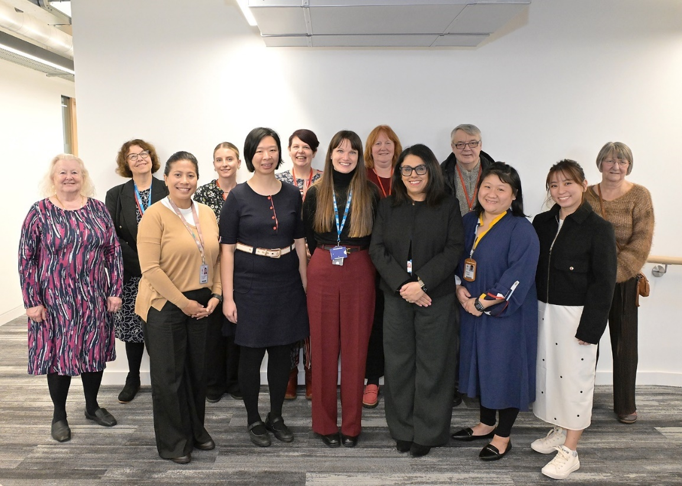
Item 3: Photograph from the ‘Meet and Greet’ with NHS Greater Manchester

- Hearing from clinicians and health and care staff with first-hand experience of the delirium pathway implementation from several locality teams and hospitals e.g. Trafford (North West Ambulance Service, Care Homes, Trafford Crisis Team, All Age Integrated Commissioning Team in the local authority), Stockport’s Urgent Care Team, Oldham (Hospital at Home and Virtual Ward), Tameside (Digital, Virtual Ward, Frailty Same Day Emergency Care), Wythenshawe’s Hospital at Home

- DU provided an induction on the visitors’ first day and weekly catch-up meetings at the end of each week of the four-week placement.
  - An overview of their four-week timetable was provided at the initial induction day, with more detailed weekly timetable delivered in advance of each new week. This included contact details for each host, travel information, and contingency planning.

- A day focused on co-production with Dementia Carers Expert Reference Group (DCERG) members and lived experience advisors seeing in practice how lived experience has driven the development of the delirium programme. The Singapore delegates learned about how DCERG was set up, its governance, and how they are embedded into projects with Dementia United. Each of the members shared their experience of being a part of DCERG and examples of projects and initiatives they’ve been involved in.
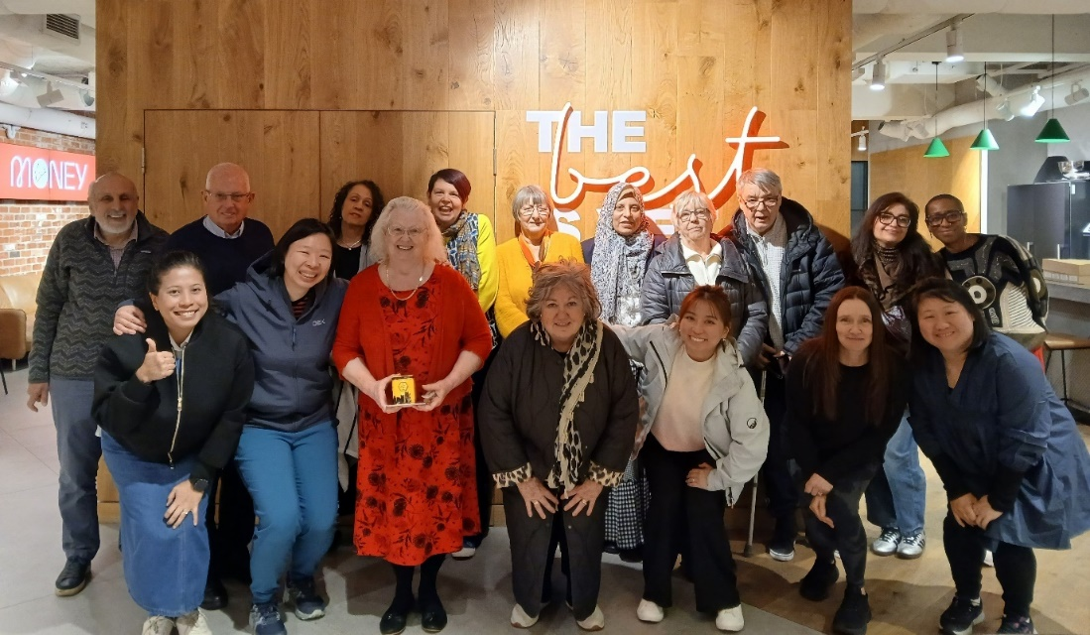
Item 2: Photograph from the co-production day with lived experience members

GM programmes and how they link with the wider admission avoidance agenda e.g. Greater Manchester Live Well event. This event brought together GM’s public services, voluntary, community, faith and social enterprise partners, Local Authorities, NHS, funders, and more to explore the journey they have been on since the 2021 Live Well Mayoral manifesto commitment, celebrate their achievements, share, learn and importantly progress as they take their neighbourhood and prevention work to the next level through GM Live Well.
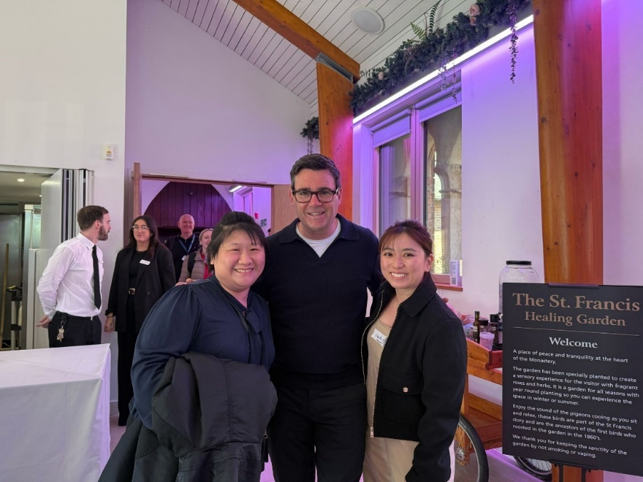
Item 3: Photograph from the event with Andy Burnham and two of the Singapore delegates

- World Delirium Awareness Day event hosted by DU with the participation of the delegates as presenters, workshop facilitators networking with over 70 people in person as part of the showcasing of best practice Dementia United’s World Delirium Awareness Day 2025 in-person health and care staff event was a huge success. - Dementia United

Feedback from Singapore delegates

Feedback on the day-to-day delivery of the observer-ship

- Staggering the receipt of the information by DU prevented information overwhelm; information we received was timely and as-and-when needed
- Weekly catchups with DU project were helpful and practical, allowing delegates to collate queries in advance
- Providing mobile numbers and transport information for each placement or hub in advance helped with contingency planning
- Delegates appreciated the consideration around mapping their learning objectives to each placement and having this in advance of each placement
- Each placement host knew information about them in advance, which was well-structured and exactly the right amount of detail

Feedback on meetings and locality placement experiences

- Gained valuable insight into diverse ways of capturing lived experience and its role in driving projects, highlighting GM as a gold-standard model for co-production. Appreciation was expressed for lived experience members who contributed to the placement—through meet and greet sessions, the WDAD event, and co-production day.
- Found the Tameside placement day to be the most structured, with individualised timetables and focused engagement with their learning objectives
- Learned how training can be tailored for different audiences, from Wythenshawe Hospital’s snakes-and-ladders board game to Tameside’s Virtual Reality training and Bolton’s interdisciplinary simulation work
- Valued opportunities for direct practice observation, such as shadowing a community nurse in Oldham
- Enjoyed the social placements options, including the Together Dementia Support choir and Dementia Disco

- It would have been beneficial for the Singapore delegates to have been able to share their slides about their work ahead with all the placements, so hosts knew their background. Time didn’t always allow for co-learning and sharing by the Singapore team.
- Delegates would have welcomed more time to discuss their work in Singapore with placement hosts. More opportunity for co-learning and sharing experiences was wanted, however time didn't always allow for this.
- They would have welcomed more free time for reflection in the timetable, as by the third week they felt exhausted as the programme had a lot packed into it

Feedback on World Delirium Awareness Day event

- Enjoyed participating with the planning as well as presenting on the day and facilitating the workshop section
- They felt privileged to be part of event and were made to feel part of the team
- People were ready to open up and share at the event which was so valuable
- The event provided a recharge, celebration and focus for their overall placement

- It can be difficult to understand someone’s role without prior knowledge when they were facilitating in the workshop
- It would be useful to be informed about different roles in advance of the event

Feedback from placement hosts

- All the locality and placement hosts reflected very positively on their experiences of hosting the Singapore delegates
- Health and care staff benefitted from hearing from Singapore delegates about their model for delivery of delirium care

Our Singapore Visit Communications Round Up which you can access via the link here www.dementia-united.org.uk/wp-content/uploads/sites/4/2025/10/Singapore-Visit-Communications-Round-Up-May-2025.docx provides further detail on each placement with quotes and feedback, such as the example below from the Frontrunner programme lead and the University of Manchester researchers.

- The Singapore team visited the Northern Care Alliance NHS Foundation Trust and partners to look at the work they’re doing to improve care for people living with delirium.
They visited Bury, Oldham and Rochdale to see how programmes like Hospital at Home and Discharge Integration Frontrunner are supporting early diagnosis, reducing hospital admissions and improving support at home.

“The clinicians were really impressed with the work we have carried out with partners. They said we cared so much for older people, respected the person and they were inspired by what they had seen. They found the visits really useful, especially because they had visited many hospitals in Greater Manchester but had a gap in their knowledge about what happens to people when they leave hospital.” - Lindsey Darley, director of the Frontrunner programme

- On a visit to the University of Manchester the Singapore delegates met with several academics to discuss a wide range of topics.
“Hosting the delegates was a very enjoyable and educational experience - this provided a platform for us to learn about their work, but also to learn more about work happening across disciplines within our own institution.” - Dr Sarah Fox, University of Manchester

- We would have welcomed more time to hear from the Singapore delegates about their model of care for people with delirium

Impact of the Singapore observer-ship

The delivery of the four-week clinical observer-ship was the priority and focus for us in DU and of this evaluation report. The project and working in partnership with so many stakeholders and in co-production with lived experience members has had further impact too.

Areas of the greatest impact from Singapore delegates

Since returning to Singapore, the delegates have taken forward a wide range of positive impactful changes, some of which are outlined below.

- Knowledge Dissemination: Shared key learnings from the UK’s community delirium pathway with internal stakeholders, including the Department of Geriatric Medicine, Population Health teams, and the Mobile Inpatient Care (MIC) @Home team.
- Workforce Training: Incorporated delirium as a core topic in MIC@Home nurse training, including a face-to-face workshop and the development of an e-learning module for all registered nurses of the institution, which achieved 90% completion and received positive feedback.
- Pathway Alignment: Initiated harmonisation of delirium management protocols across three sister institutions to ensure consistency in standards of care.
- Governance Development: Advocated for and initiated the formation of a Delirium Steering Committee to establish institution-wide standards for prevention, detection, and management.
- Service Model Enhancement: Successfully advocated for increased geriatrician involvement and secured dedicated funding within the MIC@Home programme. This has enabled the management of a growing number of patients with delirium or resolving delirium at home.
- Model Evolution: Leveraged insights from the UK’s geriatrician-led frailty pathway to develop a dedicated frailty workflow in MIC@Home, improving clinical confidence and outcomes in managing complex, frail patients in the community.

The delegates participated in an evaluation day with the DU delirium project team, at the end of the observer-ship. This included using different methods to capture all aspects of the evaluation, the item number 4 below, is the image that the delegates drew as a summary of their experiences whilst on placement in GM.
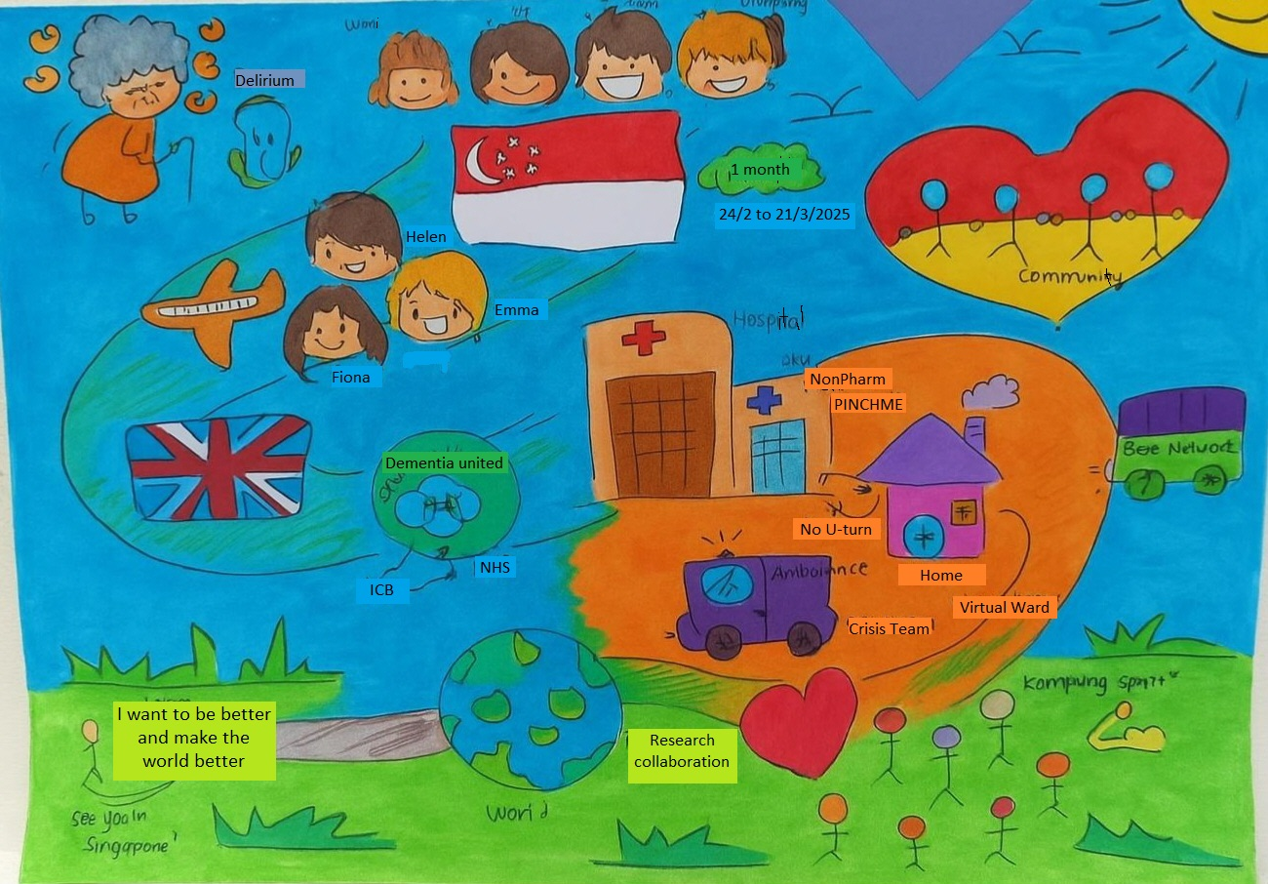
Item 4: Drawing by one of the Singapore delegates reflecting their overall experiences during the observer-ship

Areas of the greatest impact from placement hosts

Showcasing examples of impact on health and care staff from localities
- Tameside and Glossop Integrated Care NHS Foundation Trust’s Nurse
lead for delirium and dementia hosted a health and care staff delirium trust
wide learning event on the 8th of July 2025 and included a lived
experience example, a presentation on the causes, risk factors, prevention,
recognition and management of delirium, and a delirium-themed board game
with related questions. During the event staff created a wish list for items
which may prevent delirium or help to support patients who had it, which the
honorarium monies from hosting the Singapore delegates will be spent on
which includes circadian lighting.
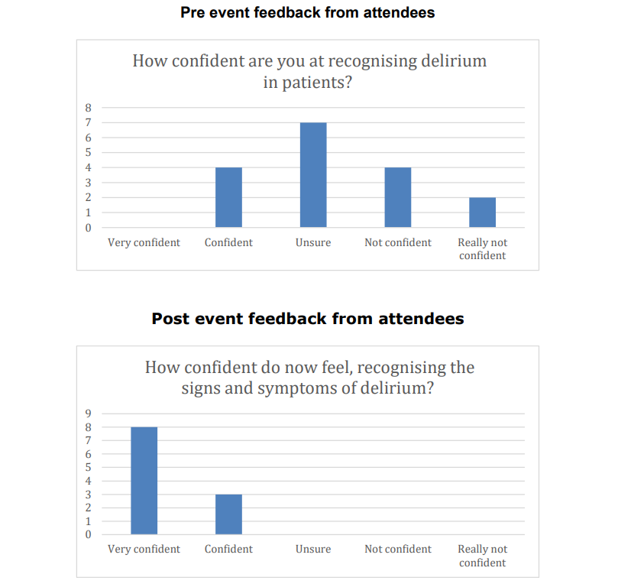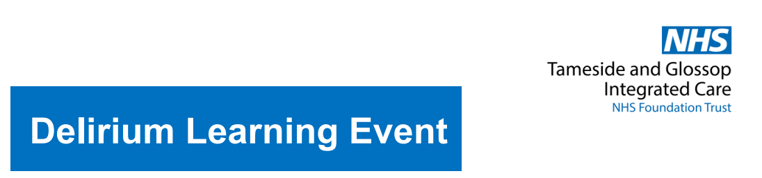
Item 5: Delirium learning event hosted by Tameside locality on 8th July 2025 pre and post event feedback
Bolton NHS Foundation Trust utilised their planned hosting of the Singapore delegates, to launch their Delirium film across the hospital which is a fabulous learning resource for health and care staff. The film can be accessed via the link here Delirium screening at Bolton NHS Foundation Trust.

Areas of the greatest impact for NHS GM
There have been several positive impacts for NHS GM and for hospitals and communities across GM, because of the Singapore delirium clinical observer-ship.

Increased DU delirium website visits with an increase of 135% when compared
with the same period in 2024 - further details in Table 3 below.

- The Delirium - Dementia United webpage page, provides hospital and community toolkits for health and care staff, translated public facing resources, carers top tips guides and training, lived experience stories and as well as training information.

 | Number of website visits
Dementia United webpages | January - June 2025 | January - June 2024 | Increase in website visits 2025 to 2024 | Increase in website visits as percentage 2025 to 2024
Delirium translated resources in 16 languages | 171 | 28 | 143 | 510%
Delirium training resources | 316 | 65 | 251 | 386%
Delirium hospital toolkit | 355 | 100 | 255 | 255%
What we do delirium | 125 | 53 | 72 | 135%
Hearing from people with lived experience of delirium news story | 106 | 52 | 54 | 103%
Delirium community toolkit | 726 | 360 | 366 | 101%
Table 3: DU delirium Website visits comparison 2025 to 2024

Recognition nationally with DU's contribution as authors and lived
experience members within focus groups during the drafting of Delirium
Matters: a new report from National Institute Health Research Policy
Research Unit in Dementia and Neurodegeneration at Queen Mary
University of London (see Appendix Five)

Lessons learned and future opportunities

There were several lessons learned during the planning and delivery of the observer-ship captured below.

Lessons learned shared by the Singapore delegates
- They needed more time to share and reflect what they provide in terms of delirium care in Singapore with the hosts and placement areas
- When designing future observer-ships to plan for more space in the timetable for reflection and downtime for the delegates
- To consider having more community placements earlier on in the timetable

Lessons learned
- The Singapore government funded observer-ship brought in monies that were utilised to secure some of the key delivery requirements, such as paying for rooms in a central Manchester location as well as providing honorarium payments to all placements or hosts and funding an in-person World Delirium Awareness Day event
- It can be hard to gage how the delegates would get from A-B and if timings were going to work, this means having some flexibility in any timings and contingency planning with all information on who to contact for every placement
- A lot of DU project team time was needed in getting hold of the right senior managers and staff to get the visit governance and practicalities signed off for a lot of the placements. If we were do this again it would be sensible to see what visits we can pull together, having hosts commit (as far as possible in advance) to a certain number of days/ hours with delegates, before offering a visit but we understand that people may not commit for a maybe visit.
- The observer-ship provided DU and NHS GM with the opportunity to reflect on how much has been achieved within the delirium project and wider DU programme
- There is immense value in harnessing lived experience members engagement as early as possible within the planning phase as this brought so many fabulous opportunities and wider impact
- There were some real challenges in securing venues for the weekly catch ups in person as well as for some of the placement/locality hosts that were in central Manchester. Some of the governance processes took a long time to work through and we would have planned to start these sooner, had we known that.
- There was a need for detailed planning and seeking advice from other GM programmes e.g. GM Cancer Academy, GM Training hub and their support was valuable when drafting the assurance and governance plan. If we were to consider a similar placement offer to an international clinical team, we would commence planning on the approval of the governance and assurance at an earlier stage, as this did take several months.

Future opportunities
The opportunities for continued learning, partnership working and quality improvement following the Singapore observer-ship, are very positive for NHS GM such as:
- DU are working as one of several key stakeholders within NHS GM’s Deteriorating patient group, to feed in the learning from this evaluation, as well as the priorities for quality improvement from the DU hosted workshop with health and care staff during the World Delirium Awareness Day event
- To harness the opportunity to work with the Singapore clinical team, to collaborate on joint research projects and publications and share learning internationally. This includes taking up opportunities to offer observer-ships to other countries and regions from across the UK.
- The Fit for the future: 10 Year Health Plan for England - executive summary focus on prevention, avoidance of admission and community management aligns with the focus of the delirium programme and resources designed to support this

- The delirium training resources and toolkits continue to be available for health and care staff, people with lived experience and the public and can all be accessed via the DU website; ensuring these resources are up to date and available for all needs to remain a priority in NHS GM given their value and website visits noted where these are being accessed
- There continues to be a need for the sharing of best practice from across all localities, providers and VCSFE partners in the assessment, treatment and management of delirium; the continued hosting of a delirium community of practice by NHS GM will enable these examples and shared learning system wide

The Singapore Observer-ship provided visiting clinicians with the invaluable opportunity to learn directly from people with lived experience of delirium, gaining a deeper understanding of the real-world impact of the condition and the support that makes a difference. This has been a fabulous opportunity to for place-based services, hospital teams, a wide range of voluntary sector groups, senior staff in NHS GM and our lived experience members to all work together with DU in delivering such a fabulous project.

A final word from NHS GM’s Delirium Clinical lead;

“Our Singapore colleagues identified Greater Manchester as a beacon of good practice in delirium care. It was a privilege to showcase the ongoing good work happening in our communities and our hospitals and enabled us to reflect on how much has been achieved over the last few years through the commitment and enthusiasm of locality teams. We learned a lot from Dr Jun Pei Lim and the team, exchanging ideas for improvement, and plan to stay in contact and collaborate on projects in the future.” - Professor Emma Vardy, NHS GM Delirium Clinical Lead, Northern Care Alliance NHS Foundation Trust Consultant Geriatrician and Frailty lead, Honorary Clinical Chair Manchester Academic Health Science Network at the University of Manchester

Acknowledgements and contact us

We would like to thank and acknowledge all our Voluntary, Community and Social, Faith, Enterprise partners, locality clinical services and teams, lived experience members, GM programme colleagues, Senior Managers from across NHS GM and locality place-based teams, wider DU team members, DU Senior Responsible Officers, Dementia Carers Expert Reference Group members, GM training hub colleagues, Singapore delegates, NHS GM finance and the NHS GM business admin team who worked to deliver such a successful observer-ship.


You can contact DU via the Email address here: gmhscp.dementiaunited@nhs.net for any of the resources mentioned in this report.

DU’s delirium resources can be accessed here Delirium - Dementia United.

Cartoon by Tony Husband
Appendices

Appendix One

GM’s delirium standards
- People over 65years and/or who have a dementia diagnosis are provided with information on signs and symptoms of delirium and prevention measures.
- 100% of patients over 65 years and/or who have a dementia diagnosis that are admitted to the acute care setting/mental health are assessed for delirium using 4AT (4AT - Rapid Clinical Test for Delirium Detection (the4at.com)) on admission.
- Every care organisation should have a standardised pathway for assessment/management of delirium.
- Family carers are provided with information and support to help support relative with delirium.
- Evidence that non-pharmacological measures/de-escalation techniques used before medication for agitation/distress.
- Delirium diagnosis should be conveyed at all transitions of care.
- All people with delirium should have multidisciplinary follow up.

GM’s evidence based seven delirium standards were co-designed with a wide range of practitioners, stakeholders and lived experience members. These delirium standards align with NICE quality statements and audit criteria.

These standards form part of a more detailed Greater Manchester Approach to Delirium - Dementia United which also includes a high-level pathway for delirium.

Appendix Two
Singapore clinician’s learning objectives
Role: Geriatric Medicine Consultant, Tan Tock Seng Hospital
Objectives:
To understand gain an understanding about Delirium care is structured across different settings in Greater Manchester, particularly with interest in management of delirium in community settings.
Learning Needs:
- Understanding about the programme: the safety nets, governance, funding models behind the delirium care program
- Tools used to triage the patients’ medical conditions, severity, as well as how the patients’ progress are monitored.
- To learn about how the program is implemented and evaluated
- To understand the resources required for the program
- To learn how patients and their care providers supported in the community.

Experience Needs:
- Observing teams at work in assisting patients with delirium to be able to recover in their own homes
- Seeing how patients are triaged in the GP clinic/ ED settings; and if any, virtual consults
- Understanding how stakeholders / partners are trained with delirium detection and management
- Learning and sharing with patients with lived-experienced of delirium
- Participation and networking at Delirium Awareness Day events

Role: Senior Occupational Therapist, Central Health
Objectives:
To understand the role an Occupational Therapist/ Physiotherapist can play as part of managing patients with delirium in community through non-pharmacological interventions
Learning Needs:
- Crisis teams’ day to day operations - in managing pt with delirium in community/ at home
- Understanding support systems or services available for caregivers in the community/ patient discharging back home with ongoing delirium
- Non-pharm intervention specifically:
- Communications strategies between caregivers and families
- Occupation engagement
- Maintaining/ promoting early movements in patients with delirium
- Sleep hygiene
- Preventing falls, home environment modification/ optimization
Experience Needs:
- Attachment to health care professionals who deliver non-pharmacological interventions in delirium management, in both acute and community settings
- Preferably to follow through with a patient from the start to the end (at point of diagnosed with delirium> managing delirium in community journey> discharge)
- Visit the different resource centres in the community that provides support to caregivers and family in managing patient with delirium at home

Role: Geriatric Medicine Advanced Practice Nurse, Tan Tock Seng Hospital
Objectives:
To develop an understanding of the role of Advanced Practice Nurse in delirium management in community
Learning Needs:
- Understand how to manage delirium patients over virtual settings / Teleconsultations.
- Gain an understanding of how community nurses collaborate in creating training programme, workflow and processes for delirium management in community.
- Learn how the community team provides support and education to patient’s caregiver in community (e.g. training program, education material, digital apps)
- Gain insight into potential/ existing challenges faced when managing person with delirium in community and ways to overcome them.
Experience Needs:
- Attachment to geriatrician and to observe how to manage patient in virtual ward
- Attachment to crisis team (Advanced Clinical Practitioners)
- Home visit with community nurse/ medical team
- Observing how training course are being planned and conducted

Role: Geriatric Nurse Clinician, Central Health

Objectives: To observe how delirium care management is effectively implemented in the community in Greater Manchester, with a focus on remote monitoring and timely escalation measures. As we intend to establish a home-based delirium care service that improves patient outcomes and supports caregivers through implementing best practices for delirium care management in the context of mobile inpatient care.

Learning Needs:
- To gain insights into community-based delirium care, focusing on the integration of monitoring (e.g. vital signs, behavioural monitoring, blood indices) and appropriate responses.
- To identify challenges and solutions in managing delirium beyond the inpatient setting and assess the implementation and utility of escalation guidelines/protocols for structured, responsive interventions.
- To gain exposure to non-pharmacological interventions for patient-centred delirium care in the community, including the use of environmental modification and cognitive therapy.
- To appreciate the training and development of nursing skills in delirium care and formulate a plan for capacity building, focusing on alleviating caregiver preparedness through engagement, empowerment and resources providence.
- To appreciate on efforts focusing on staff welfare and resilience navigating changes and new initiatives.
- To appreciate the processes in assessing and evaluating programme success.
- To appreciate autonomous care collaboration and integration across settings and roles: from acute to primary care; community care partners; and patients and their caregivers.
Experience Needs:
- To observe daily clinical and administrative operations of the care team (and the factors driving service adoption, use of remote monitoring, and virtual consultation), from initial acute care to inpatient care, to the transition and to long term care.
- To appreciate the following components of community-based care:
- Funding model(s), charges, service capacity and resource management
- Individual and team capability development to cope with exponential growth of the service
- Caregiver management: initiation, provision and support of intuitive response resources, patient motivation and community activation.
- To observe the operations, roles and the funding models of community care agencies and resource centres.

Appendix Three
Patient leaflet
Singapore health colleagues to visit Greater Manchester to learn more about our work on delirium

Greater Manchester’s dementia programme (called Dementia United) and a wide range of locality teams are hosting a team of four health staff from Singapore, who are coming to Greater Manchester from February 24th to March 21st, 2025.
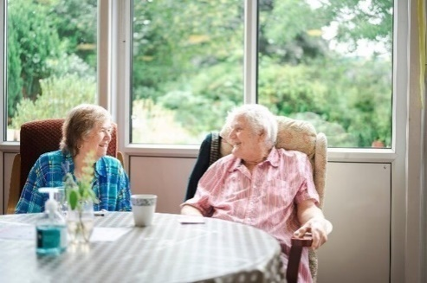

Who are the Singapore team that are coming over to Greater Manchester?
The Singapore team consists of a Consultant Geriatrician, as well as advanced nurse practitioners and an occupational therapist.

What are the Singapore team doing here in Greater Manchester?
The Singapore team are keen to observe how we deliver training and manage delirium in hospital and community settings. They will not be delivering any care or treatment. They are observing our staff in several settings, such as general practice, hospital wards, and with Urgent Care Teams. They may also go on some home visits. The Singapore team will always be accompanied by our health and social care staff and are bound by the same confidentiality rules. Please let our staff member or family member know if you would rather not have the Singapore health colleagues accompanying staff who are seeing you at home, in a care home, on the wards, or in a GP surgery.

How can I find out more?
You can find out more about our work on delirium here www.dementia-united.org.uk/delirium. We have provided a link here www.dementia-united.org.uk/news/2024/02/22/delirium-top-tips-for-carers-and-family-members to our top tips guide and video for carers and family members that you may find useful.

If you have any further questions, please get in touch with Dementia United via email: gmhscp.dementiaunited@nhs.net

Appendix Four

Week 1: Extract from the Timetable for delirium clinical observer-ship (remaining weeks’ timetables followed on)

 | Morning | Information | Break / travel | Afternoon | Information
Monday February 24th | 10:00 – 12:45  Dementia United introduction to the observer-ship & Dementia United programme. | Main contacts  Helen Pratt  helen.pratt5@nhs.net  (+44) 79764 42088  Fiona Black  f.black1@nhs.net  Location  Friend’s Meeting House  6 Mount St, Manchester M2 5NS  Travel  Walking distance from Manchester City Centre. A short walk from St Peter's Square tram station.  On arrival  Helen Pratt will meet you in the reception.  Learning and experience objectives  - A warm welcome and outline of the observer-ship programme; booking in tickets for events, sharing of the detailed timetable  - NHS system & Local Authorities  - National drivers for the delirium programme e.g. Long-Term Plan, Urgent Care | 12.40 to 13.30  Lunch provided. | 13:30 – 15:00  Dementia United introduction to the delirium programme. | Learning and experience objectives  - Greater Manchester (GM) system and programmes  - How the delirium programme links in with the wider networks across GM  - Localities in Greater Manchester and how we link in with these within the delirium programme  - Examples of the locality relationships within the delirium programme in planning for placements over the next 4 weeks

Appendix Five
Delirium Matters: priorities and opportunities for health and social care policy in England Delirium Matters: a new report from DeNPRU-QM – NIHR Policy Research Unit in Dementia and Neurodegeneration at Queen Mary University of London

The Delirium Matters report outlines five urgent policy recommendations to improve care and outcomes:
- Better Data Collection: Gather comprehensive national data on delirium across health and social care settings to understand and manage it effectively.
- Consistent Terminology: Always use the term “delirium” in policies and clinical settings to ensure clarity and seriousness
- Avoid Preventable Harm: Implement existing safety policies and interventions to reduce avoidable harm caused by delirium.
- Focus on Surgical Care: Target settings where delirium is common, such as post-surgery, with improved screening and care measures.
- Strengthen Community Care: Ensure home-care programs can identify and manage delirium, reducing unnecessary hospital admissions.

