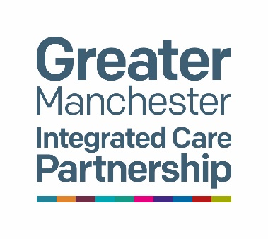


Singapore Clinical Observer-ship
Communications Round Up
February 24th to March 21st 2025

Contents
Meet and Greet with NHS Greater Manchester 2
Trafford pathway in care homes 4
Coproducing culturally appropriate translated delirium resources 6
South Asian Dementia Hub 7
Wythenshawe hospital showcasing innovative approaches to training delivery and hospital at home services 10
Together in Song Gospel Choir 11
Visit to the Greater Manchester Brain Health Centre 12
Greater Manchester Live Well event 13
Dementia Disco: Changing the narrative of dementia. One disco at a time. 14
Ageing Well, Greater Manchester Combined Authority 15
Visit to Tameside and Glossop Integrated Care NHS Foundation Trust 17
Greater Manchester best practice delirium in-person event on World Delirium Awareness day 2025 18
University of Manchester visit 19
Bolton delirium simulation training session 20
Dementia United lived experience co-production day 22
Stockport Urgent Community Response/Virtual Ward 24
Discharge integration frontrunner programme and hospital at home 25
Dementia United’s work on delirium 26

Meet and Greet with NHS Greater Manchester

A team of clinicians from Singapore travelled to Greater Manchester for a month-long study visit to learn how health and care services work together to improve delirium care. The city-region’s proactive, community-focused approach is helping more people receive early diagnosis and support at home, reducing hospital admissions and improving outcomes.

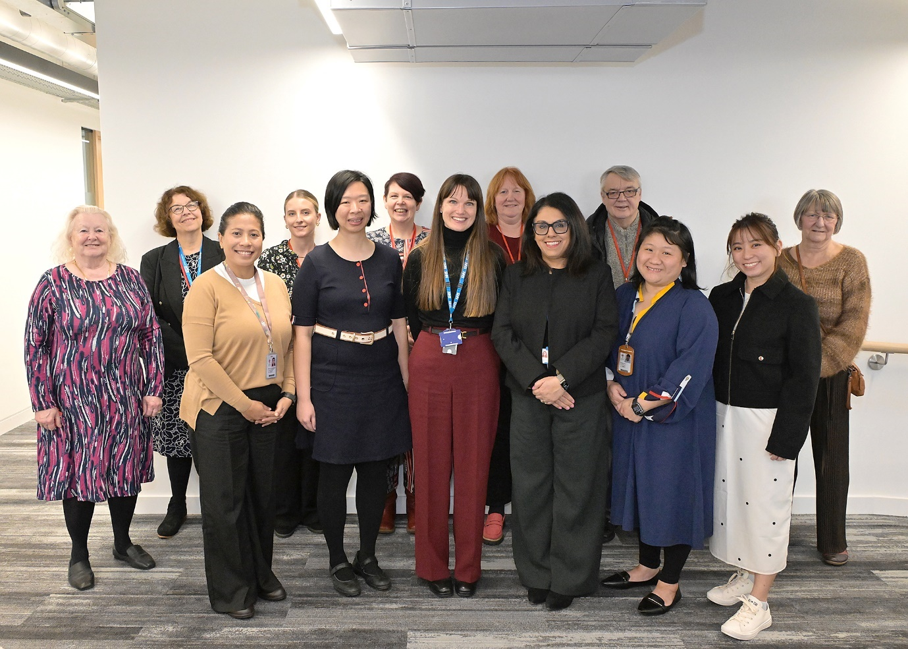

L to R: Ruth Turner, Dementia Carers Expert Reference Group, Dementia United; Gill Walters, Senior Programme Manager, Dementia United; Siti Norwani Binte Mohamed Hussain, Senior Occupational Therapist, Tan Tock Seng Hospital, Singapore; Fiona Black, Project Support Officer, Dementia United; Dr Lim Jun Pei, Consultant, Geriatric Medicine, Tan Tock Seng Hospital, Singapore; Helen Pratt, Senior Project Manager, Dementia United; Dr Claire Lake, Deputy Chief Medical Officer, NHS Greater Manchester; Liz Brookes, Dementia Carers Expert Reference Group, Dementia United; Professor Manisha Kumar, Chief Medical Officer, Caldicott Guardian, NHS Greater Manchester; John O’Doherty, Living with Dementia Group, Dementia United; Joey Yeo Jiayang, Geriatric Nurse Clinician, Tan Tock Seng Hospital, Singapore; Ng Wan Ring, Geriatric Medicine Advanced Practice Nurse, Tan Tock Seng Hospital, Singapore; Ann Booth, Dementia Carers Expert Reference Group, Dementia United.

Led by Helen Pratt (Senior Project Manager) and Professor Emma Vardy (Consultant Geriatrician) within the Dementia United programme, Greater Manchester has developed one of the most progressive and integrated delirium care models in England, making significant strides in community-based detection, prevention, and management:

- Keeping people safe at home: The Greater Manchester Community Delirium Toolkit, used by GPs, nurses, paramedics, urgent care teams and care home staff, has been instrumental in keeping people with delirium out of hospital, ensuring they receive prompt care in familiar surroundings. In Stockport, 97% of patients received an urgent assessment within two hours from the Urgent Community Response team, with 88% of those showing signs of delirium safely supported at home, preventing hospital admission.
- Raising awareness in local communities: A multilingual delirium advice leaflet, available in 16 languages (Making delirium information more accessible in Greater Manchester - Dementia United), has made vital information accessible to diverse communities, helping families spot early signs and seek help.
- Improving early detection: Hospitals in Manchester and Bolton have introduced digital screening tools to detect delirium faster, leading to quicker interventions and better patient outcomes.

We are immensely proud that our work in Greater Manchester is gaining international attention. Our goal has always been to improve how we recognise and care for people with delirium, keeping them well at home whenever possible. To see our model inspire global learning is a testament to the dedication of our health and care teams, as well as the invaluable contributions of people with lived experience and the voluntary sector in shaping and delivering better care. It was great to host colleagues from Singapore and share knowledge on improving community-based delirium care.
Dr Manisha Kumar, Chief Medical Officer for NHS Greater Manchester

We visited Greater Manchester to see how delirium is addressed across different care settings. We were particularly interested in how various care providers work together to improve delirium detection and management, from patients' homes all the way to hospital care. We’ve had the chance to engage with a wide range of stakeholders, from patients with lived experience to NHS leaders. We have been inspired by the passion and collaboration between those affected by delirium and the teams working to improve care. We are also incredibly grateful for the warm hospitality we’ve received.
Dr Lim Jun Pei, Consultant in Geriatric Medicine at Tan Tock Seng Hospital (TTSH) in Singapore

The Singapore clinical observer-ship was a huge success and a unique opportunity to celebrate Greater Manchester having an international reputation for clinical and research excellence in delirium assessment and care. The passion of senior project manager Helen Pratt for the delirium programme shone through and illustrated what can be achieved, through clinical collaboration and working in partnership with experts by experience, in system wide large-scale change. The Greater Manchester team have forged a lasting partnership with colleagues from Singapore and there are already plans in progress for ongoing sharing of learning and research collaboration”. Professor Emma Vardy

Trafford pathway in care homes

Caroline Mather, commissioning support officer in the council’s all-age commissioning team, along with Francine Whittaker from the Trafford Crisis Team and Sara Harris from Northwest Ambulance Service hosted the Singapore colleagues at Trafford Town Hall.

This joint opportunity allowed them to showcase the work of their teams, including last year's delirium pilot. Two local care home providers, Chantal Corneill, clinical lead and compliance manager at Wyncourt Nursing Home in Timperley, and Godfrey Tadera, registered manager at Lady of the Vale Nursing Home in Bowdon, both of whom were part of the pilot, shared case studies, outcomes, and reflections from their perspective.

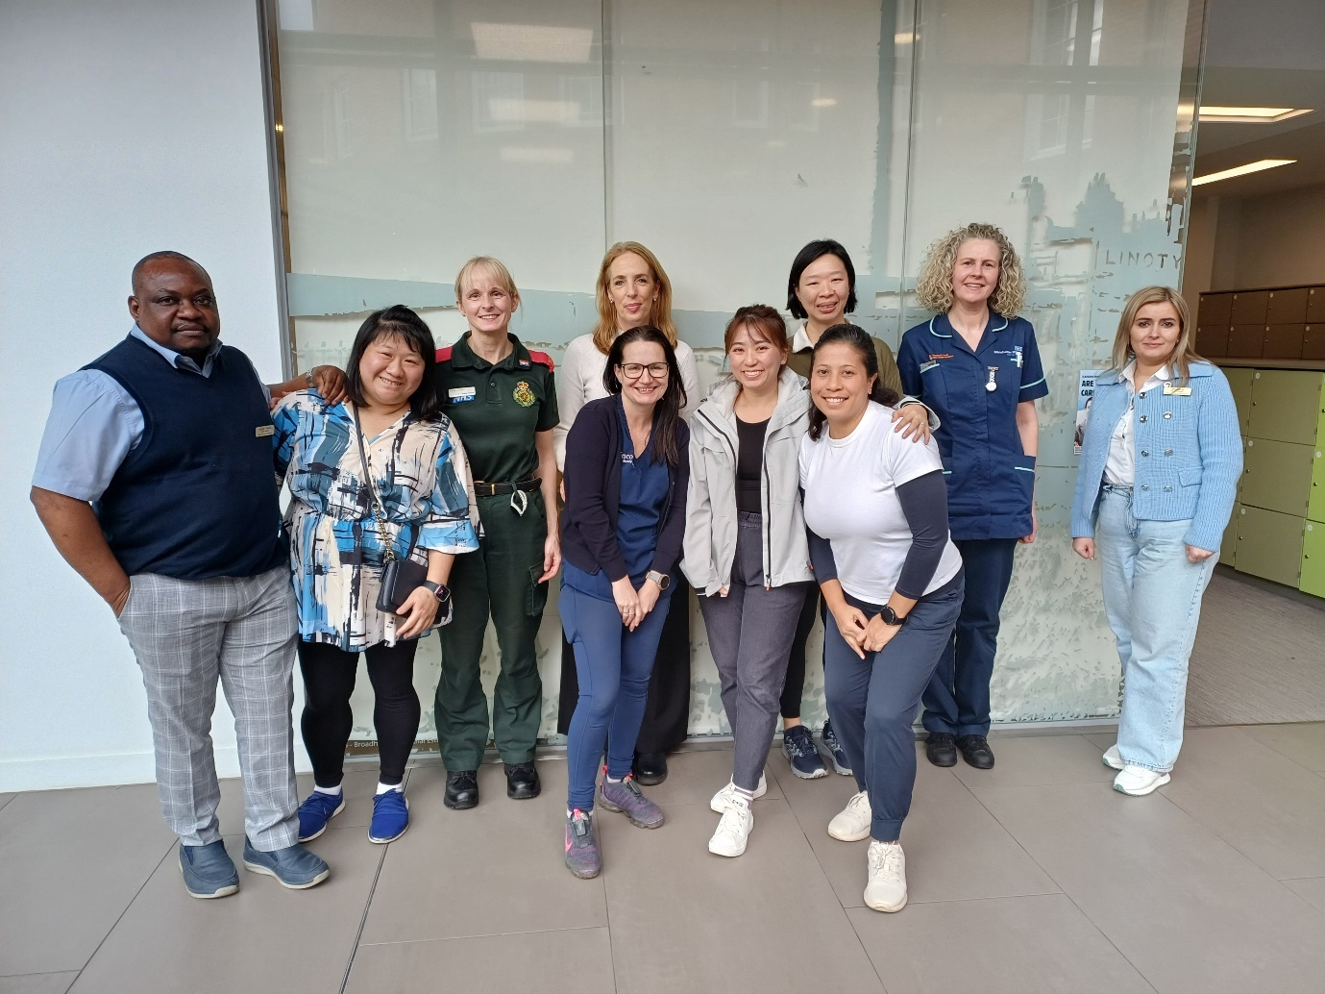

Back row from L to R: Godfrey Taderera, Lady of the Vale Care Home; Joey Yeo Jiayang, Geriatric Nurse Clinician, Tan Tock Seng Hospital, Singapore; Sara Harris, Northwest Ambulance Service, Caroline Mather. All Age Integrated Commissioning Team, Trafford Council; Dr Lim Jun Pei, Consultant, Geriatric Medicine, Tan Tock Seng Hospital, Singapore; Francine Whittaker, Trafford Crisis Team; Otilia Leonte, Deputy of Lady of the Vale care home. Front row from L to R: Chantal Corneil, Wyncourt Nursing Home; Ng Wan Ring, Geriatric Medicine Advanced Practice Nurse, Tan Tock Seng Hospital, Singapore; Siti Norwani Binte Mohamed Hussain, Senior Occupational Therapist, Tan Tock Seng Hospital, Singapore.

The visit received positive feedback, with the Singapore team expressing their appreciation for the insights gained during their time with the teams.

A team full of enthusiasm and infectious positivity. I hope the Singapore team will carry forward the good work.

I just wanted to say how lovely it was to meet everyone and have a lovely positive afternoon. In times where we are so busy just stopping to talk to like-minded professional about patient care is a joy.

Coproducing culturally appropriate translated delirium resources

Following the production of the delirium leaflet, Dementia United consulted with the Dementia Carers Expert Reference Group members who asked about the provision of the leaflet as a translated version, given the vital importance of raising awareness about delirium across our diverse communities. Abdul Shakoor from Tameside, Oldham and Glossop Mind checked the translations and took them out to seven community groups where 153 people had an opportunity to review and comment. Everyone found the leaflets very easy to read and understand. This review also highlighted that 90% of people had no understanding or awareness of what delirium is or what the what symptoms are. Abdul Shakoor was able to deliver awareness sessions using the leaflet.
www.dementia-united.org.uk/translated-delirium-resources/

The visit by professionals from Singapore was a great opportunity to meet and learn many new ideas and things. All who came to visit were so enthusiastic about my work and they were very friendly and supportive. This visit was really a great chance for me to learn. Abdul Shakoor, Tameside, Oldham and Glossop Mind.

South Asian Dementia Hub

Oldham memory assessment service and Dr Kershaw's Hospice developed a new dementia hub for people from South Asian heritage. It builds on their existing work to support people with dementia, after a need for more support and access was identified. The Singapore team visited the hub which is hosted at the Fatima Women's association in Oldham. The hub runs every last Thursday of the month from 11am to 1pm for people living with dementia and their carers. There are lots of activities including arts and crafts, a home remedies corner, massages, with food served at the end of the session. The hub has partner organisations including Age Concern, Pennine Care, Tameside and Oldham MIND and Dr Kershaw’s hospice who can offer support.

It was a pleasure to have the team at our event. They interacted with the patients and shared experiences. The members really enjoyed their conversations with the team.

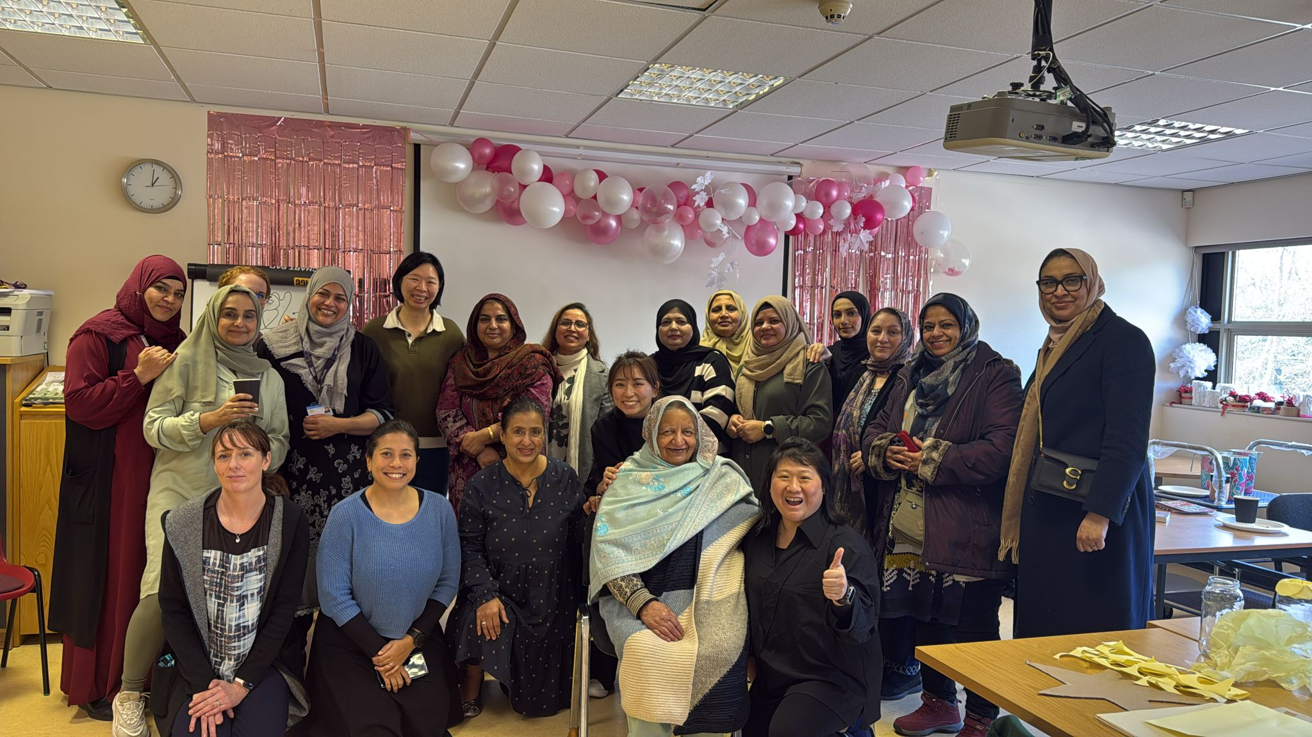

Featuring Joey Yeo Jiayang, Geriatric Nurse Clinician, Tan Tock Seng Hospital, Singapore; Dr Lim Jun Pei, Consultant, Geriatric Medicine, Tan Tock Seng Hospital, Singapore; Ng Wan Ring, Geriatric Medicine Advanced Practice Nurse, Tan Tock Seng Hospital, Singapore; Siti Norwani Binte Mohamed Hussain, Senior Occupational Therapist, Tan Tock Seng Hospital, Singapore; Fauzia; Farhanda; Ishrat; Uzma; Shabana and visitors and volunteers.

Oldham Hospital at Home and Acute Frailty Services

Oldham showcased a variety of services for older people and people with dementia. Sarah Campbell (autonomous practitioner) and Lorena Hulme (team lead) from the hospital at home team explained how services are delivered to patients at home and how delirium is assessed. Dr Yen-Jei Chen and Takudzwa Zindoga (specialist physiotherapist) described how the frailty Same Day Emergency Care (SDEC) unit works and links with services such as hospital at home and the Urgent Care Response Team. Professor Emma Vardy discussed how her frailty hot clinic operates and how she has achieved significant waiting list reductions.

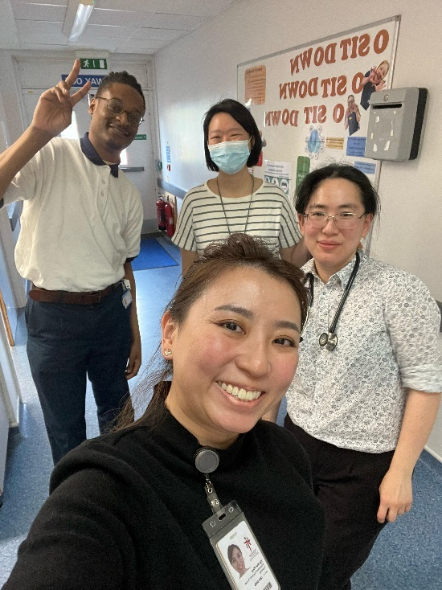
Back row from L to R: Takudzwa Zindoga; Dr Lim Jun Pei, Consultant, Geriatric Medicine, Tan Tock Seng Hospital, Singapore. Front row from L to R: Ng Wan Ring, Geriatric Medicine Advanced Practice Nurse, Tan Tock Seng Hospital, Singapore; Dr Yen-Jei Chen.

Hosting Dr Lim Jun Pei and colleagues was a great opportunity for us to showcase all the fantastic work we have been doing to improve delirium care in Greater Manchester. The team was very impressed with our holistic, person-centred approach when visiting the Oldham Hospital at Home team, Oldham Frailty Same Day Emergency Care service and seeing the NCA Dementia Frontrunner work. Our teams should be rightly proud of all that they have achieved. It was also an opportunity for us to learn from international colleagues.
Professor Emma Vardy, who led the implementation of Hospital at Home at NCA and is expert advisor to Dementia United

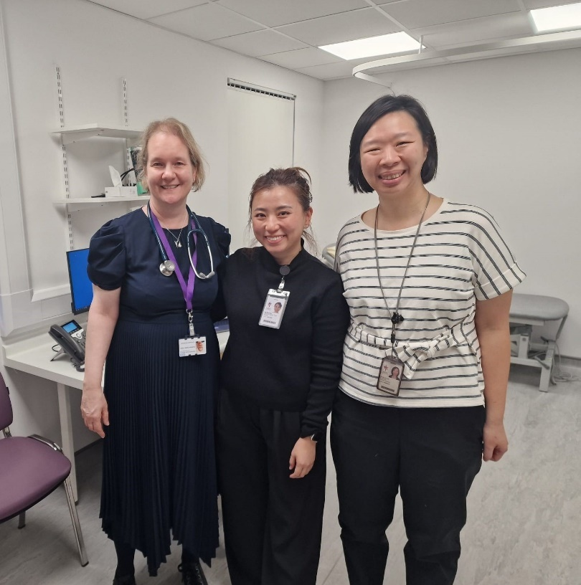

From L to R: Professor Emma Vardy, Consultant Geriatrician; Ng Wan Ring, Geriatric Medicine Advanced Practice Nurse, Tan Tock Seng Hospital, Singapore; Dr Lim Jun Pei, Consultant, Geriatric Medicine, Tan Tock Seng Hospital, Singapore.

Wythenshawe hospital showcasing innovative approaches to training delivery and hospital at home services

Lesley Baston, Sam Turner (Dementia Practitioners), and Dr Kate Gitsham (Consultant Geriatrician) from Manchester Foundation Trust hosted the Singapore colleagues at Wythenshawe Hospital. This enabled the showcasing of the innovative training approaches that Lesley and Sam have been taking forward to improve delirium awareness and management. Kate provided an overview of the frailty and hospital at home services, which incorporate delirium assessment and management.

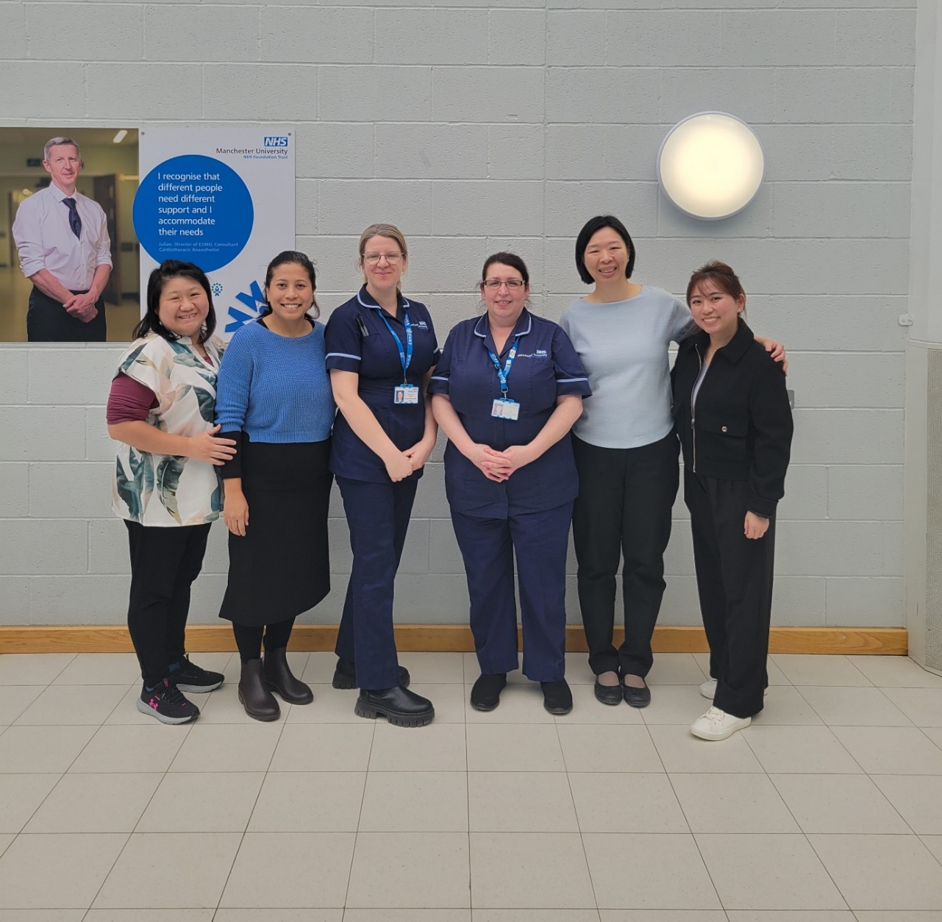

From L to R: Joey Yeo Jiayang, Geriatric Nurse Clinician, Tan Tock Seng Hospital, Singapore; Siti Norwani Binte Mohamed Hussain, Senior Occupational Therapist, Tan Tock Seng Hospital, Singapore; Sam Turner and Lesley Baston, Dementia Practitioners within Wythenshawe and Trafford hospitals (Manchester University NHS Foundation Trust); Dr Lim Jun Pei, Consultant, Geriatric Medicine, Tan Tock Seng Hospital, Singapore; Ng Wan Ring, Geriatric Medicine Advanced Practice Nurse, Tan Tock Seng Hospital, Singapore

It was an excellent opportunity to show case what we do and also to learn from them and above all meet some lovely people. Wythenshawe Hospital

Together in Song Gospel Choir

We all know that singing can cheer us up, give us more energy and help us to connect when we’re singing together. The monthly choir sessions are about much more than just singing. There are opportunities to chat, play group games, enjoy refreshments but the singing is also fantastic. Anyone living with dementia can come and enjoy the music and friendly atmosphere and people come to life when they sing. You can find out more about the choir on the Dementia United website.

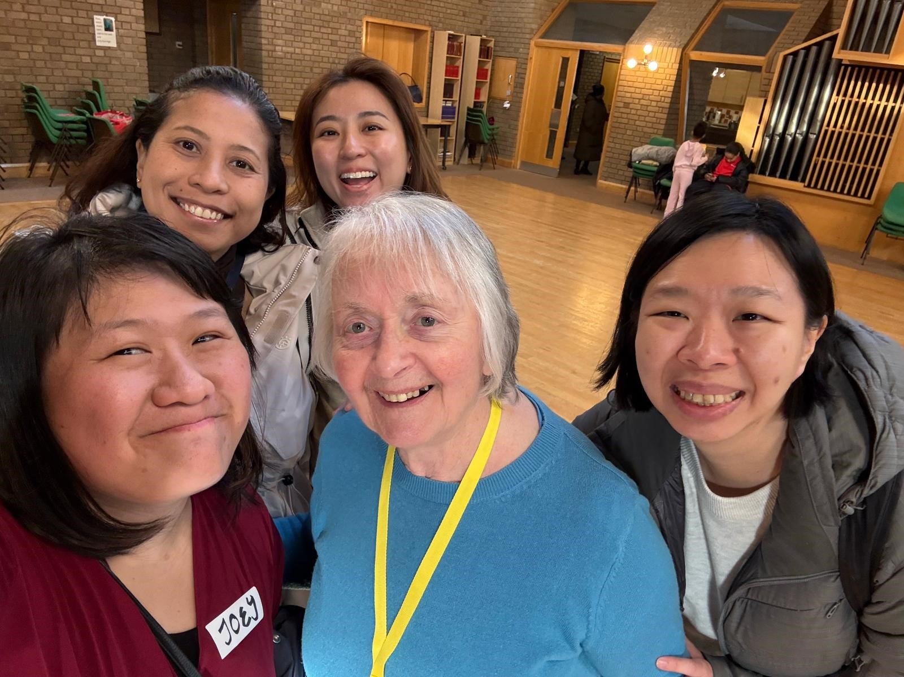

From L to R: Joey Yeo Jiayang, Geriatric Nurse Clinician, Tan Tock Seng Hospital, Singapore; Siti Norwani Binte Mohamed Hussain, Senior Occupational Therapist, Tan Tock Seng Hospital, Singapore; Ng Wan Ring, Geriatric Medicine Advanced Practice Nurse, Tan Tock Seng Hospital, Singapore; Carol Bodey, Together Dementia Support volunteer; Dr Lim Jun Pei, Consultant, Geriatric Medicine, Tan Tock Seng Hospital, Singapore.

They said they’d like to take our enthusiastic and skilled volunteers back with them! Dementia choir with Together Dementia Support

The delegates were a delight to have as guests at our Together In Song session. They joined in the singing and chatted to volunteers and members with dementia. Dementia choir with Together Dementia Support

Visit to the Greater Manchester Brain Health Centre

Led by Dr Ross Dunne and Professor Adam Greenstein, the Brain Health Centre has already demonstrated the feasibility of building a multidisciplinary team (MDT) across Manchester’s largest healthcare providers including later life psychiatry, geriatric medicine, primary care, neuroradiology, neurology, nuclear medicine, mental health nursing and allied health practitioners. This MDT has expertise in early disease diagnosis, combining neuroimaging, cognitive assessment, and lumbar puncture/ cerebrospinal fluid procedures in a ‘one stop shop’ for diagnostic assessment.

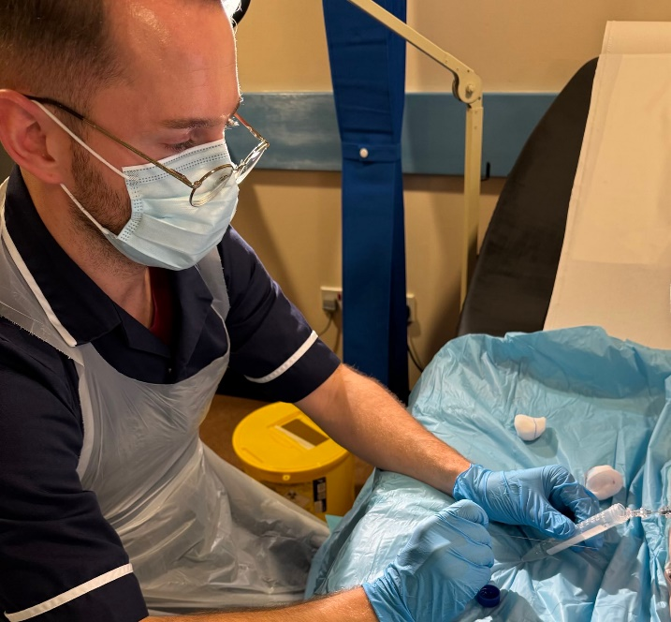
Alex Cook, Memory Assessment Practitioner, Brain Health Clinic, performing a lumbar puncture (for cerebral-spinal fluid testing for Alzheimer’s diagnosis)

The Brain Health Centre offers the potential to transform dementia from a condition that requires palliative care from the point of diagnosis to one that receives disease modifying treatments to slow progression and provide a transformation in quality of life, for patients, carers and their loved ones.

Greater Manchester Live Well event

The Singapore team took part in the Greater Manchester Live Well event at Gorton Monastery. The event brought together GM’s public services, voluntary, community, faith and social enterprise partners, Local Authorities, NHS, funders, and more to explore the journey they have been on since the 2021 Live Well Mayoral manifesto commitment, celebrate their achievements, share, learn and importantly progress as they take their neighbourhood and prevention work to the next level through GM Live Well.

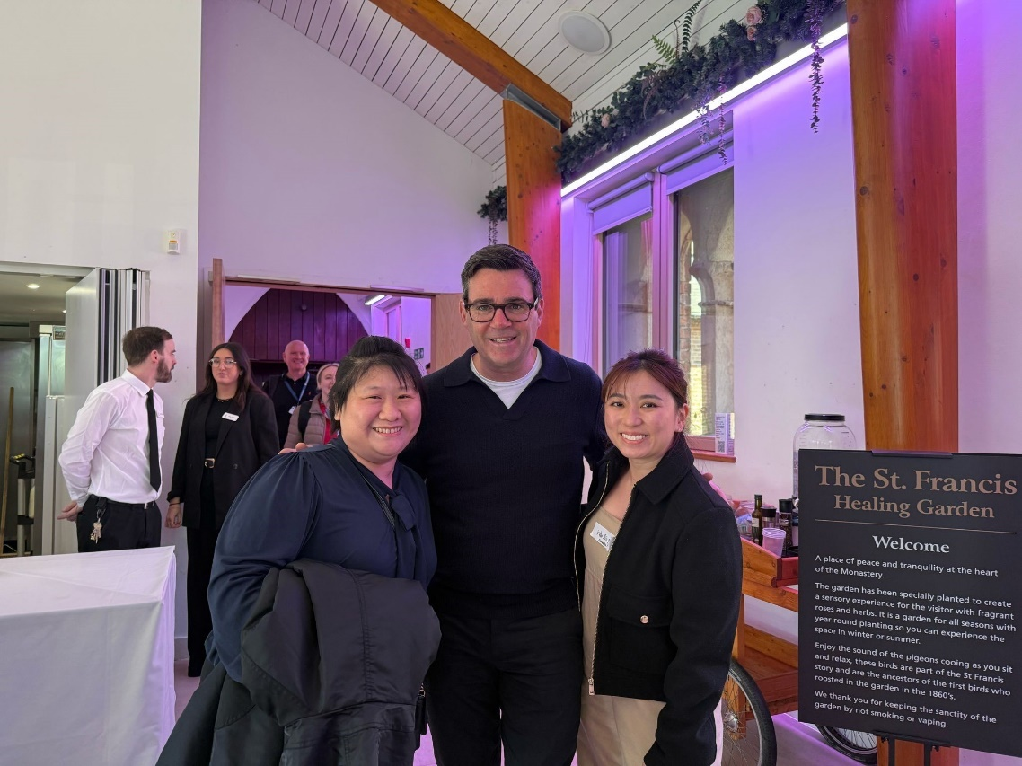
L to R: Joey Yeo Jiayang, Geriatric Nurse Clinician, Tan Tock Seng Hospital, Singapore; Andy Burnham, Mayor of Greater Manchester and Ng Wan Ring, Geriatric Medicine Advanced Practice Nurse, Tan Tock Seng Hospital, Singapore

Dementia Disco: Changing the narrative of dementia. One disco at a time.

Dementia Disco organise free-to-attend, regular discos for people with dementia, their carers, family and friends. Our Singapore visitors were delighted to join the team at a disco in Ladybridge Park Residents Club in Cheadle Hulme during their visit.
About Dementia Disco
There is a wealth of evidence to support the idea that music can have a positive impact on people’s mental health. Our aim is to use music to inspire memories, conversation, and friendships in and between people living with dementia.

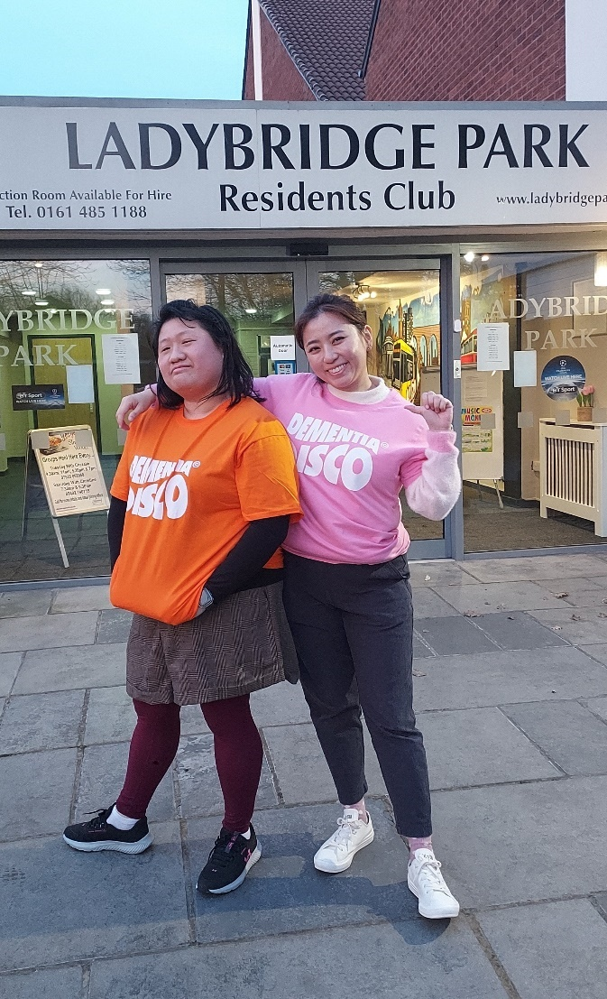
L to R: L to R: Joey Yeo Jiayang, Geriatric Nurse Clinician, Tan Tock Seng Hospital, Singapore and Ng Wan Ring, Geriatric Medicine Advanced Practice Nurse, Tan Tock Seng Hospital, Singapore

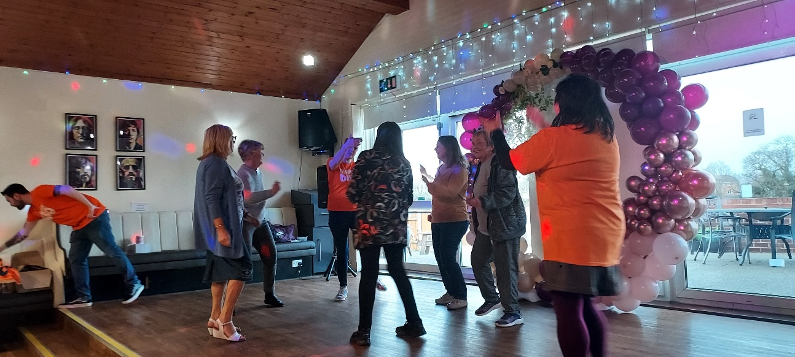
From L to R: Dan, Jean, Sandra, Philippa, Karen, Diane, Joey.

Ageing Well, Greater Manchester Combined Authority

Our 2034 vision is a Greater Manchester where older people are living longer, healthier lives
www.greatermanchester-ca.gov.uk/what-we-do/ageing/ageing-well/

The team from Tan Tock Seng Hospital were welcomed to the Gorton Community Centre for a session to learn about the Age-Friendly Greater Manchester approach. They learned about the background and work of the GM Ageing Hub and initiatives such as the Ageing in Place Pathfinder project. Some key areas of discussion surrounded working in co-production, and how the GM Ageing Hub build up programmes from a community level.

It was a really great session. They were super interested in our approach, particularly learning about co-production, and building up programmes from a community level

After the presentation, the team visited the Ageing in Place Pathfinder Gorton Crafts group and were able to engage with the residents during their craft session and walk around the
community garden.

On behalf of the GM Ageing Hub, and the Healthy Me Healthy Communities team at Gorton Central, we absolutely loved the experience and getting to meet the team Singapore, they were incredibly friendly and very keen to get stuck into meeting the local residents and exploring the craft session and community garden! We really hope they enjoyed their afternoon with us.
Beth Mitchell, Ageing Well Programme Manager, Greater Manchester Ageing Hub, Greater Manchester Combined Authority

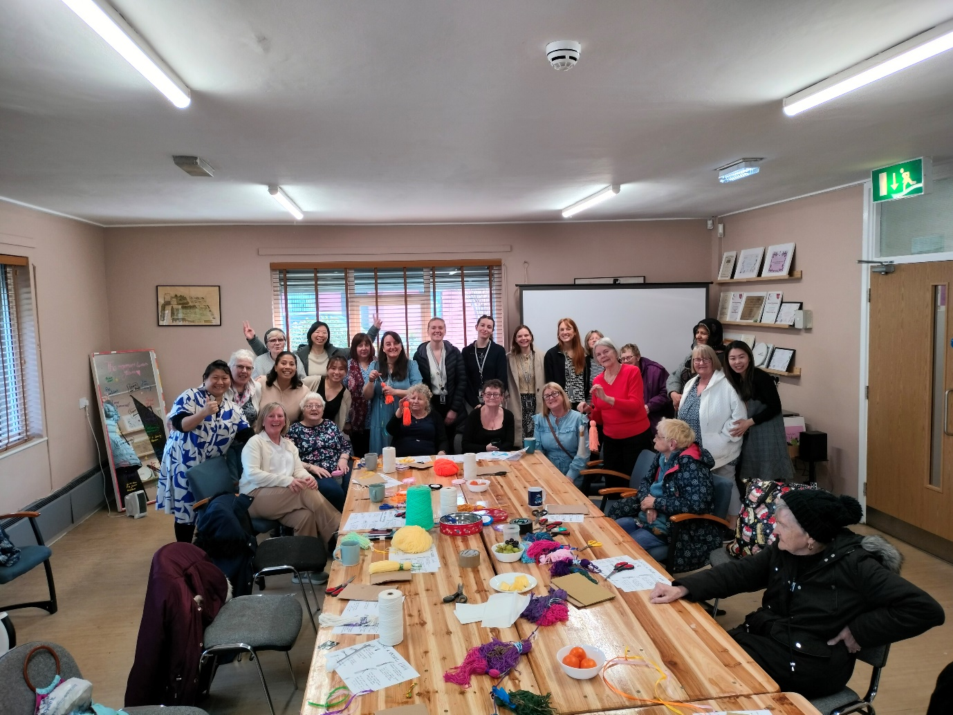

Front row L to R: Amanda Aitken, Ageing in Place Development (AIP) Co-ordinator and Healthy Me Healthy Communities (HMHC); Stella Buckley, AiP Volunteer and Participant; Joan Clarke, Ageing in Place AND HMHC Volunteer and Trip Ambassador and Age Friendly Manchester Board Member; Janet Knights, HMHC Volunteer; Donna Enright, Ageing in Place Volunteer; Jane Whisker; Sheila Capstick. Back row L to R: Joey Yeo Jiayang, Geriatric Nurse Clinician, Tan Tock Seng Hospital, Singapore; Deana Lamb, Siti Norwani Binte Mohamed Hussain, Senior Occupational Therapist, Tan Tock Seng Hospital, Singapore; Ng Wan Ring, Geriatric Medicine Advanced Practice Nurse, Tan Tock Seng Hospital, Singapore; Jenney Steel; Beth Mitchell, Ageing Well Programme Manager, Greater Manchester Ageing Hub, GMCA; Sara Griffiths, Project Officer, Greater Manchester Ageing Hub GMCA; Bianca Rossetti, Strategic Partnerships Manager, Centre for Ageing Better; Lauren Foster, Project Manager-Ageing in Place Pathfinder, GM Ageing Hub, GMCA; Pat Callaghan; Catherine Smith; Shazia Zaman; Pat Lamb; Miu Tsui, Project manager AiPP, Southway Housing; Lorraine Lowe; Dr Lim Jun Pei, Consultant, Geriatric Medicine, Tan Tock Seng Hospital, Singapore; Melanie Tupman; Rose Wood front of picture in black coat

Visit to Tameside and Glossop Integrated Care NHS Foundation Trust

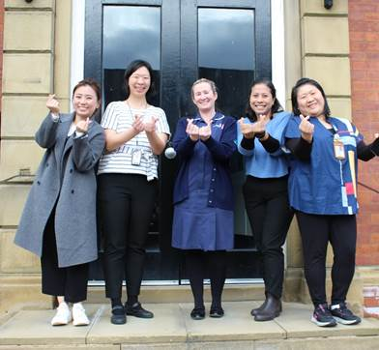
From L to R: Ng Wan Ring, Geriatric Medicine Advanced Practice Nurse, Tan Tock Seng Hospital, Singapore; Dr Lim Jun Pei, Consultant, Geriatric Medicine, Tan Tock Seng Hospital, Singapore; Kellie Smart, Lead Admiral Nurse; Siti Norwani Binte Mohamed Hussain, Senior Occupational Therapist, Tan Tock Seng Hospital, Singapore; Joey Yeo Jiayang, Geriatric Nurse Clinician, Tan Tock Seng Hospital

Their visit provided an invaluable opportunity to exchange knowledge and best practices in delirium care. During their time at Tameside the Singapore visitors met a variety of teams, including the digital health team, crisis team, emergency department, frailty same day emergency care and integrated urgent care team gaining insight into Tameside’s approach to supporting patients with delirium.

The photograph features Lead Admiral Nurse Kellie Smart and the Singapore team forming a symbol commonly recognised in Singapore as love, reflecting the shared commitment to patient care that connects us across borders.

We are deeply grateful for the opportunity to host the Singapore team and share meaningful discussions. Thank you for your time and insights. We look forward to continuing our exchange of knowledge and learning together in the future

Greater Manchester best practice delirium in-person event on World Delirium Awareness Day 2025

The delirium best practice event on World Delirium Awareness Day was a great success, with over 70 people attending from across a wide variety of health and care settings including voluntary sector, care homes, hospices, community teams, primary care as well as hospitals and mental health providers. During the event we heard from some fantastic speakers, including our visiting Singapore colleagues, on a range of topics. You can find out more here: https://tinyurl.com/yc3zd3hs

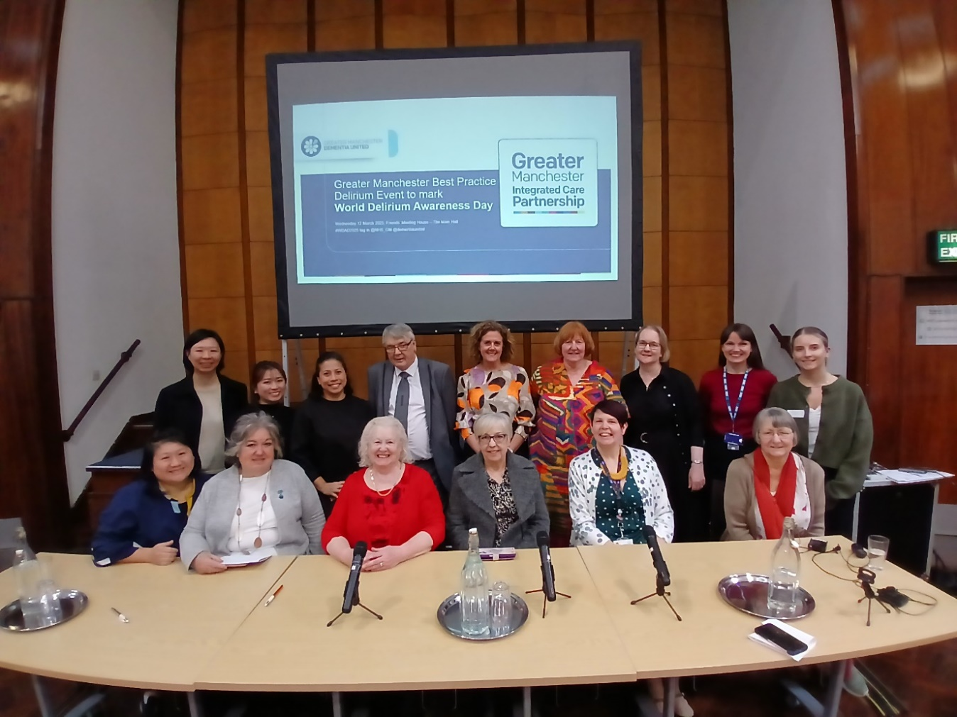

Back row L to R: Dr Lim Jun Pei, Consultant, Geriatric Medicine, Tan Tock Seng Hospital, Singapore; Ng Wan Ring, Geriatric Medicine Advanced Practice Nurse, Tan Tock Seng Hospital, Singapore; Siti Norwani Binte Mohamed Hussain, Senior Occupational Therapist, Tan Tock Seng Hospital, Singapore; John O’Doherty, Living with Dementia Group, Dementia United; Jayne Etches, Interim Macmillan Specialist Palliative Care Team Service Lead, Stockport NHS Foundation Trust; Liz Brookes, Dementia Carers Expert Reference Group, Dementia United: Professor Emma Vardy, Consultant Geriatrician; Dr Claire Lake, Deputy Chief Medical Officer, NHS Greater Manchester; Fiona Black, Project Support Officer, Dementia United. Front row L to R: Joey Yeo Jiayang, Geriatric Nurse Clinician, Tan Tock Seng Hospital, Singapore; Marion Coleman, Dementia Carers Expert Reference Group; Ruth Turner, Dementia Carers Expert Reference Group, Dementia United; Pat O’Doherty, Dementia Carers Expert Reference Group; Helen Pratt, Senior Project Manager, Dementia United; Ann Booth, Dementia Carers Expert Reference Group, Dementia United.

I just wanted to follow up and say a huge thank you for providing such an informative and thought-provoking workshop. I can’t tell you how much I enjoyed it, and I’ve already made plans to share the information with the rest of the organisation. Care home manager

University of Manchester visit

On a visit to the University of Manchester the team met with several academics to discuss a wide range of topics including: partnership working with Manchester Camerata and how social research has helped develop and promote their music-making programme with people with dementia; exploring how sensory and embodied practices of care can improve care services and change the quality of socially engaged arts practices; research that’s focused on the mechanisms underlying reduced cerebral blood flow in dementia models and the use of novel therapeutics approaches; research that’s targeting microglia (resident immune cells of the central nervous system) to develop therapeutic treatment for Alzheimer's disease; the development and evaluation of a digital program (KOKU-LITE) to prevent falls and improve well-being in people living with dementia in the community; novel cross disciplinary approaches to dementia care; projects that aim to improve hospitalised care for people living with dementia.
Hosting the delegates was a very enjoyable and educational experience - this provided a platform for us to learn about their work, but also to learn more about work happening across disciplines within our own institution. University of Manchester

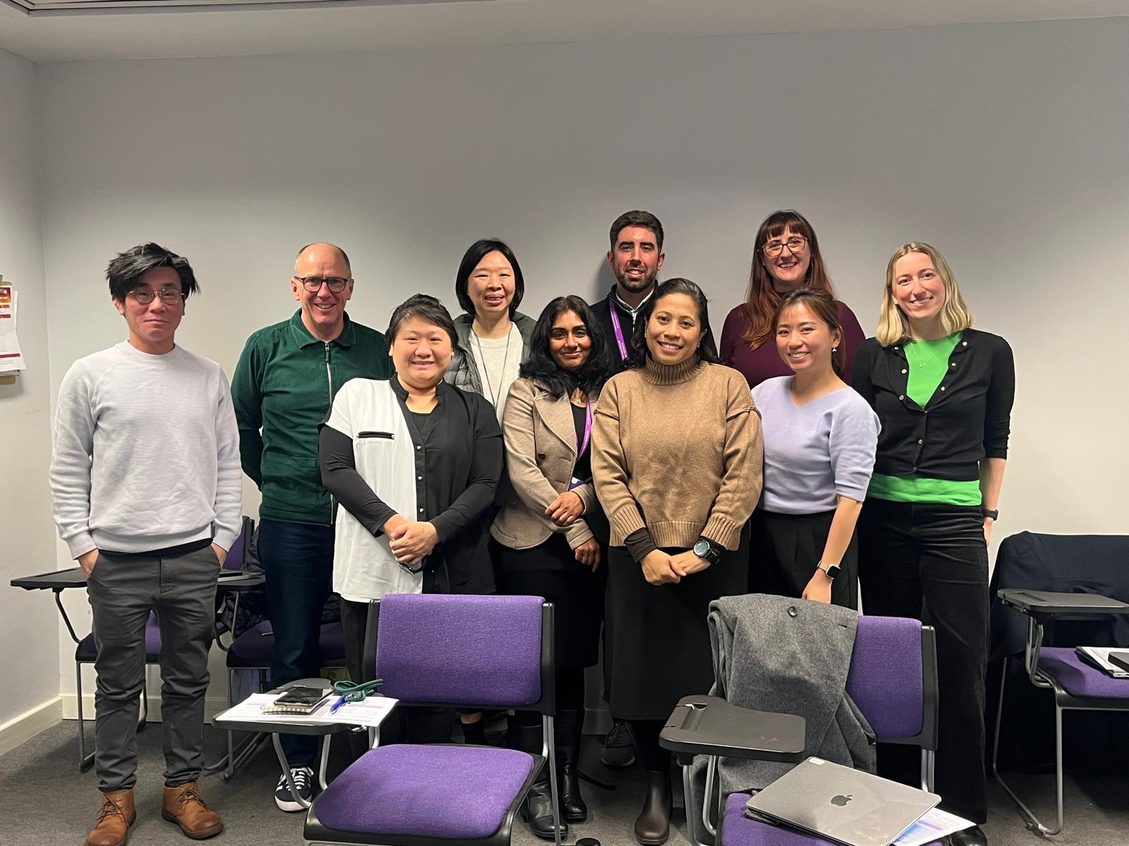
From L to R: from left to right we have Roy Ng, Research Explorer; James Thompson, Research Explorer; Joey Yeo Jiayang, Geriatric Nurse Clinician, Tan Tock Seng Hospital, Singapore; Jun Pei, Geriatric Medicine Consultant, Tan Tock Seng Hospital, Singapore; Jaheeda Gangannagaripalli, Healthy Ageing Theme, NIHR; Harry Pritchard, Research Explorer; Siti Norwani Binte Mohamed Hussain, Senior Occupational Therapist, Tan Tock Seng Hospital, Singapore; Sarah Fox, Dementia Research Fellow, NIHR; Ng Wan Ring, Geriatric Medicine Advanced Practice Nurse, Tan Tock Seng Hospital, Singapore; Emma Elliott, Research Associate, Healthy Ageing theme, NIHR.

Bolton delirium simulation training session

The Singapore team took part in creating a real-life scenario that they might experience in practice but in a simulated setting. During the session they worked together to complete a full assessment and look after a patient with delirium. The team had the opportunity to take on different roles, observe each other and offer support and to use the documentation 4AT. This innovative training teaches participants how to practically deal with delirium with an emphasis on a multi-disciplinary approach where effective communication is key.

“The feedback as part of the feedback for the simulation training has been very positive. It’s something very new for foundation trainees and it`s not the scenario they expect in simulation as they always suspect an emergency or a dying patient. It`s part of emphasising that delirium is a serious condition. They are surprised to hear the mortality is actually higher than myocardial infarction and sepsis”. Dr Gopalakrishnan Deivasikamani, Consultant, Elderly Medicine, Bolton NHS Foundation Trust.

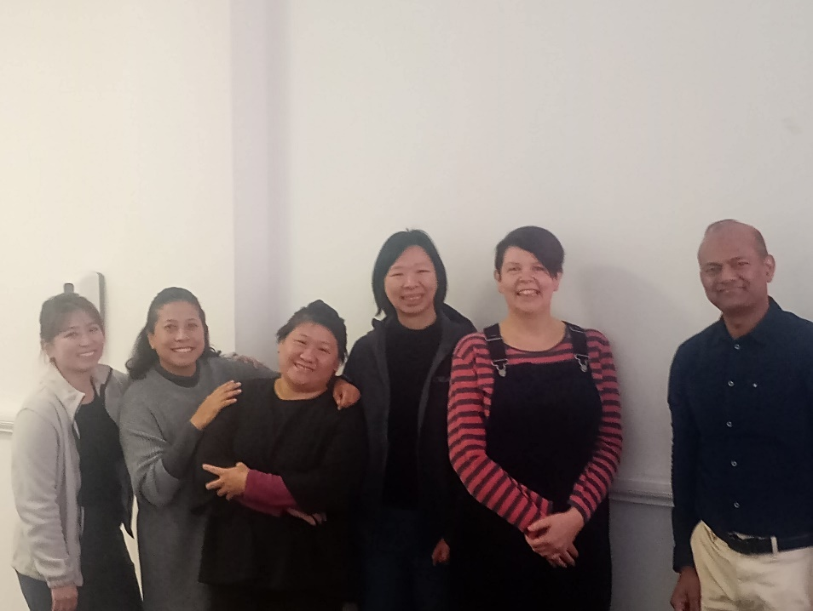

From L to R: Ng Wan Ring, Geriatric Medicine Advanced Practice Nurse, Tan Tock Seng Hospital, Singapore; Siti Norwani Binte Mohamed Hussain, Senior Occupational Therapist, Tan Tock Seng Hospital, Singapore Joey Yeo Jiayang, Geriatric Nurse Clinician, Tan Tock Seng Hospital, Singapore; Jun Pei, Geriatric Medicine Consultant, Tan Tock Seng Hospital, Singapore; Helen Pratt, Senior Project Manager, Dementia United, NHS Greater Manchester; Dr Gopalakrishnan Deivasikamani, Consultant, Elderly Medicine, Bolton NHS Foundation Trust.

Bolton News item
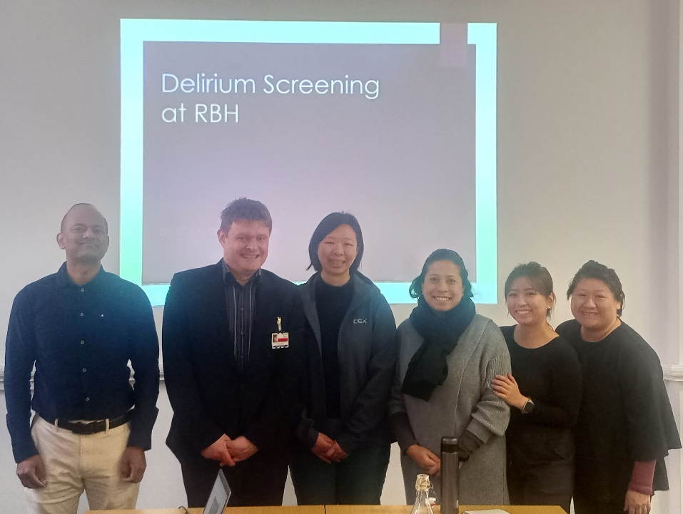

From L to R: Dr Gopalakrishnan Deivasikamani, Consultant, Elderly Medicine, Bolton NHS Foundation Trust; David Neilson, Lead Admiral Nurse, Bolton NHS Foundation Trust; Jun Pei, Geriatric Medicine Consultant, Tan Tock Seng Hospital, Singapore; Siti Norwani Binte Mohamed Hussain, Senior Occupational Therapist, Tan Tock Seng Hospital, Singapore; Ng Wan Ring, Geriatric Medicine Advanced Practice Nurse, Tan Tock Seng Hospital, Singapore; Joey Yeo Jiayang, Geriatric Nurse Clinician, Tan Tock Seng Hospital, Singapore.

Dementia United lived experience co-production day

We aim to engage lived experience in all aspects of the programme. This can be through existing groups and networks or directly as part of specific pieces of work. As part of the visit, the Singapore delegation attended one of the Dementia Carers Expert Reference Group (DCERG) meetings to learn about co-production.

The team learned about how DCERG was set up, its governance, and how they are embedded into projects with Dementia United. Each of the members shared their experience of being a part of DCERG and examples of projects and initiatives they’ve been involved in.

The delegates shared some of their key takeaways and learnings they will take back to share with colleagues in Singapore:

- Sharing the value of co-production and harnessing the value and strength of the caregiver into their work.
- The value and impact of lived experience and personal stories, for example when giving presentations and doing teaching sessions with nurse, so that the staff can “stand in the person’s shoes”.
- Learning of the importance of lived experience which can have more of an impact than papers and journals.
- Valuing personal stories and measures over other Key Performance Indicators.
- Taking creative approaches back to the team in Singapore.
- Ideas about how to change culture.
- How lived experience can influence high level policy.

Our face-to-face meetings are always welcome but yesterday was exceptional. Everything ran smoothly. It was good to hear from our friends from Singapore to talk about their own service and hospital. What a great day.
Ruth Turner, Dementia Carers Expert Reference Group, Dementia United.

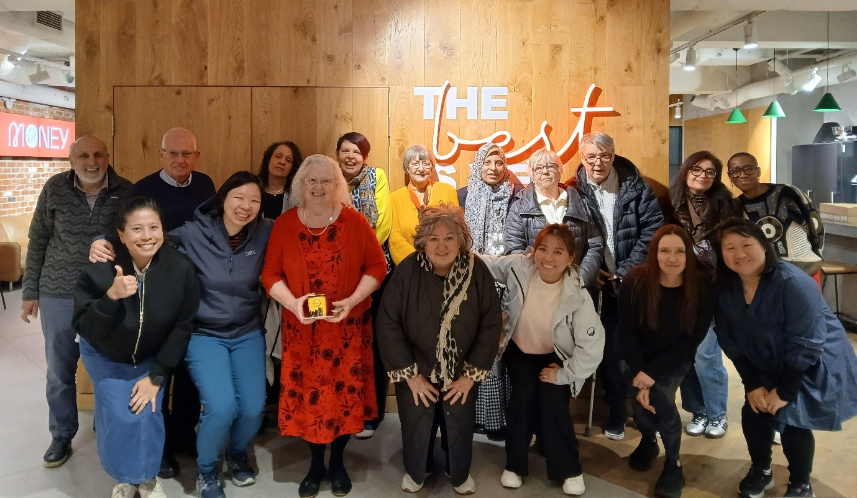

Back row: Jeff Seneviratne, Dementia Carers Expert Reference Group; Paul Smithies, Dementia Carers Expert Reference Group; Kim Hughes, Dementia Carers Expert Reference Group; Helen Pratt, Project Manager, Dementia United; Ann Booth, Dementia Carers Expert Reference Group; Amal Morsi, Project Manager, Dementia United; Pat O’Doherty, Dementia Carers Expert Reference Group; John O’Doherty, Living with Dementia Group; Jagdish Brar-Orgill, Dementia Carers Expert Reference Group; Leah Payne, Dementia Carers Expert Reference Group. Front row: Siti Norwani Binte Mohamed Hussain, Senior Occupational Therapist, Tan Tock Seng Hospital; Jun Pei, Geriatric Medicine Consultant, Tan Tock Seng Hospital; Ruth Turner, Dementia Carers Expert Reference Group; Marion Coleman Dementia Carers Expert Reference Group; Ng Wan Ring, Geriatric Medicine Advanced Practice Nurse, Tan Tock Seng Hospital; Kellie Leatherbarrow, Dementia Carers Expert Reference Group; Joey Yeo Jiayang, Geriatric Nurse Clinician, Tan Tock Seng Hospital.

Stockport Urgent Community Response/Virtual Ward

The Singapore clinicians met with members of the urgent community response, virtual ward and neighbourhood advanced clinical practitioner teams to find out more about how their approach is providing earlier diagnosis and support at home, reducing hospital admissions and improving outcomes.

With the new community approach in Stockport, 97% of patients now receive an urgent assessment within two hours from the Urgent Community Response team, with 88% of those showing signs of delirium safely supported at home, preventing hospital admission. Earlier assessment improves outcomes for these patients.

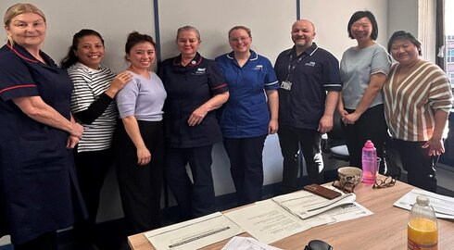
From L to R: Kay Bottrell, Service Lead; Siti Norwani Binte Mohamed Hussain, Senior Occupational Therapist, Tan Tock Seng Hospital; Ng Wan Ring, Geriatric Medicine Advanced Practice Nurse, Tan Tock Seng Hospital; Julie Gardner, Team Lead; Emma Clayton – Team Lead; Ed Fitzpatrick, Mental Health Liaison Practitioner; Jun Pei, Geriatric Medicine Consultant, Tan Tock Seng Hospital; Joey Yeo Jiayang, Geriatric Nurse Clinician, Tan Tock Seng Hospital.

Discharge integration frontrunner programme and hospital at home

The Singapore team visited the Northern Care Alliance NHS Foundation Trust and partners to look at the work they’re doing to improve care for people living with delirium. The delegation visited Bury, Oldham and Rochdale to see how programmes like Hospital at Home and Discharge Integration Frontrunner are supporting early diagnosis, reducing hospital admissions and improving support at home.

The clinicians were really impressed with the work we have carried out with partners. They said we cared so much for older people, respected the person and they were inspired by what they had seen. They found the visits really useful, especially because they had visited many hospitals in Greater Manchester but had a gap in their knowledge about what happens to people when they leave hospital. Lindsey Darley, director of the Frontrunner programme

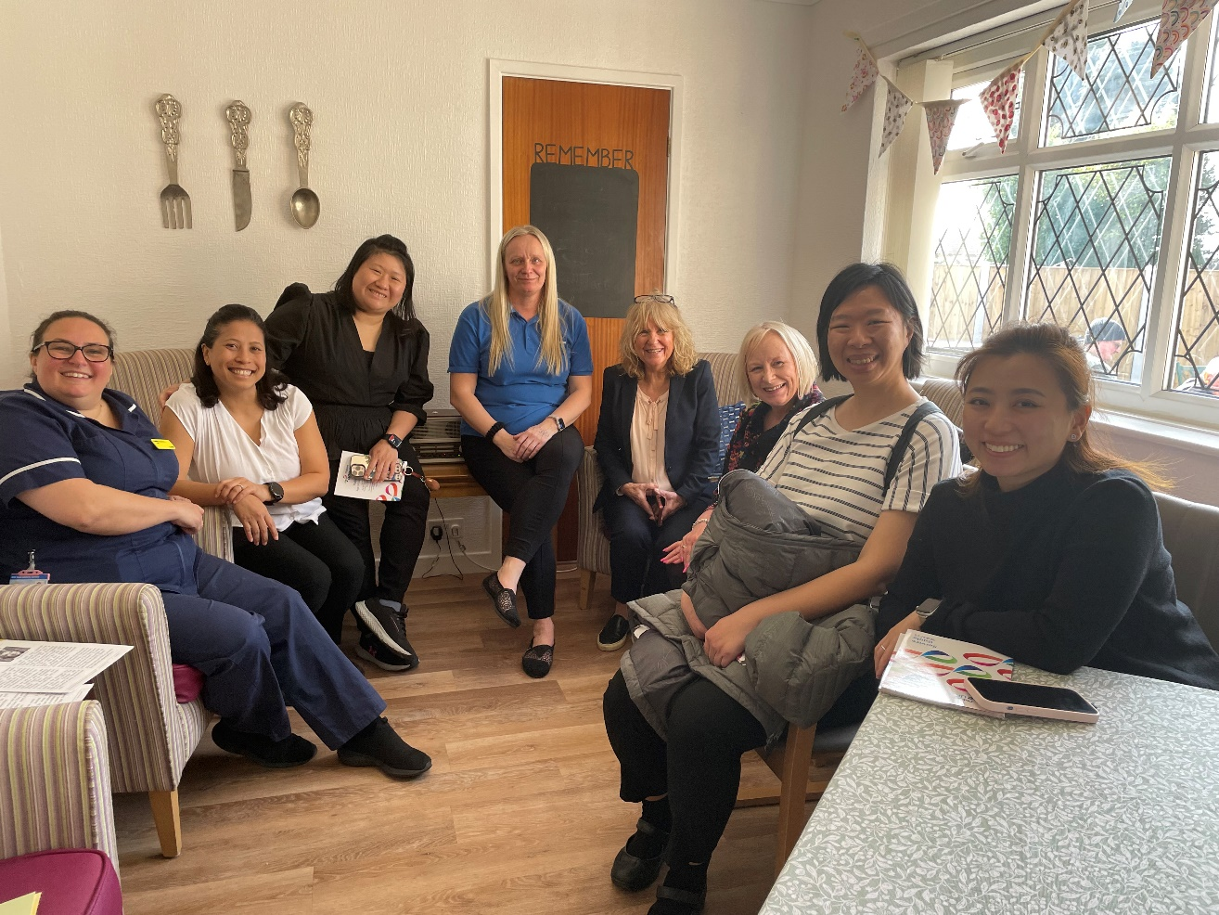

From L to R: Lucie Kershaw (NCA), Siti Norwani Binte Mohamed Hussain, Senior Occupational Therapist, Tan Tock Seng Hospital; Joey Yeo Jiayang, Geriatric Nurse Clinician, Tan Tock Seng Hospital; Yvonne Lee, Age UK Oldham; Kryshia Winkler, Age UK Oldham; Susan Fletcher, Age UK Oldham; Jun Pei, Geriatric Medicine Consultant, Tan Tock Seng Hospital; Wan Ring, Geriatric Medicine Advanced Practice Nurse, Tan Tock Seng Hospital.

Hosting Dr Jun Pei Lim and colleagues was a great opportunity for us to showcase all the fantastic work we have been doing to improve delirium care in Greater Manchester. The team was very impressed with our holistic, person-centred approach when visiting the Oldham Hospital at Home team, Oldham Frailty Same Day Emergency Care and seeing the NCA Dementia Frontrunner work. Our teams should be rightly proud of all that they have achieved. It was also an opportunity for us to learn from international colleagues.
Professor Emma Vardy who led the implementation of Hospital at Home at NCA and is expert advisor to Dementia United

NCA news item

Dementia United’s work on delirium


Cartoon by Tony Husband

As part of our system quality improvement programme, we have a project that focuses on improving the detection, treatment and management of delirium. Delirium is a condition which causes a short-term confused state and develops over hours and days, as a result of underlying illness. People living with dementia are more likely to experience delirium and if undetected and treated, it can lead to much poorer outcomes. Dementia United developed a Greater Manchester approach to delirium with a person-centred pathway and key standards focused on early detection, assessment and treatment. These standards form the basis of the three areas of the delirium work programme outlined as: Greater Manchester community delirium toolkit and resources; Greater Manchester hospital toolkit and resources; Delirium training and resources. You can find out more about our work here

Delirium news stories 2024/4

- Dementia United’s World Delirium Awareness Day 2025 in-person health and care staff event was a huge success.
- Learning from Greater Manchester’s delirium pathway
- Greater Manchester’s collaborative approach to delirium attracts international attention
- High impact change model on dementia and delirium
- Dementia United presents: Greater Manchester best practice delirium in-person event on World Delirium Awareness Day 2025
- Working to make dementia and delirium data easier to access and understand
- Dementia United’s delirium online training for carers and family members on 16th May 2024.
- Greater Manchester’s best practice delirium webinar 13th March 2024
- World Delirium Awareness Day 2024
- Dementia United are launching the refreshed Greater Manchester delirium hospital and community toolkits.
- Delirium: Top tips for carers and family members

You can contact Dementia United here: gmhscp.dementiaunited@nhs.net

